Project Osborne

TargetPlan Screens

Functional Specification

Version 1.0

# Revision History

|  |  |  |  |
| --- | --- | --- | --- |
| **Date** | **Version** | **Revised by** | **Summary of Changes** |
| 12/12/2014 | 1.0 | Sue Allwood | First Draft |
|  |  |  |  |
|  |  |  |  |
|  |  |  |  |
|  |  |  |  |

# Contents

1 Revision History 2

2 Contents 3

3 Review/Sign Off 4

4 Document References 4

5 Project Osborne – TargetPlan Screens 5

5.1 Introduction 5

5.2 Document Purpose 5

5.3 Scope 6

5.3.1 In Scope 6

5.3.2 Out of Scope 6

5.4 User Journey 7

6 Use Case Packages 9

6.1 Use Case Diagram – Amended TargetPlan Screens 10

6.1.1 OZUC001 – TargetPlan Home Page 11

6.1.2 OZUC002 - TargetPlan Profile Widget 17

6.1.4 Example of the Profile in Accumulation Mode 19

6.1.5 Example of the Profile in Decumulation Mode 19

6.1.6 OZUC003 – Send Message 20

6.1.7 OZUC004 – Pensions Summary 23

6.2 Use Case Diagram – Joining Wizard 27

6.2.1 OZUC005 – Navigation Panel 28

6.2.2 OZUC006 – Introduction Screen 31

6.2.3 Joining – Introduction Example Screen Shot 34

6.2.4 OZUC007 – Important Information Links 35

6.2.5 OZUC008 – Policy Conditions 39

6.2.6 OZUC009 – View/Change Personal Details 44

6.2.7 OZUC010 – View/Change Contact Details 47

6.2.8 OZUC011 – Modeller Link 51

6.2.9 OZUC012 – Income 58

6.2.10 OZUC013 – Joining Fund Choices Details 65

6.2.11 OZUC014 – Disinvestment Choices 71

6.2.12 OZUC015 – IFA Details 77

6.2.13 OZUC016 –Bank Details 83

6.2.14 OZUC017 – Confirmation 89

6.2.15 OZUC018 – Next Steps 97

6.3 Use Case Diagram – New Target Plan Screens 102

# Review/Sign Off

This document will be reviewed and signed off as follows:

|  |  |  |  |  |
| --- | --- | --- | --- | --- |
| **Name** | **Department** | **Review** | **Sign Off** | **Date** |
|  | Bus Ops |  | X |  |
|  | Bus Ops | X |  |  |
|  | Bus Ops | X |  |  |
| Andy Mayman | Bus Ops |  | X |  |
|  | Bus Ops |  | X |  |
|  | Bus Ops | X |  |  |
|  | Bus Ops | X |  |  |
| Mark Naylor | A&T | X |  |  |
| Tim Halliday | A&T |  | X |  |
| Dan Aves | A&T | X |  |  |
| Mark Beard | A&T | X |  |  |
| James Jarvis | A&T | X |  |  |
| Vikas Dhimole | TCS | X |  |  |

# Document References

The following documents have been used to reference in the writing of this Functional Specification:

|  |  |  |  |
| --- | --- | --- | --- |
| **Document Type** | **Document Reference** | **Document Author** | **Status** |
| BRD | Retirement Options Requirements_Extract_Final Draft_31_10_14.docx | Faye Hird | Draft |
| Product Spec | Compass Product Specification | Nigel Cracknell | Draft |

# Project Osborne – TargetPlan Screens

## Introduction

From 6th April 2015 the legislation around what a member has to do with their Pension Pot is changing. This means that instead of taking 25% of their pension pot as a Tax Free Lump Sum and using the remainder to buy an Annuity the member has more choices.

In addition to the traditional method described above the member can use their Pension Pot to receive an income.

This means that at retirement instead of the member taking all their money away from BlackRock there is an opportunity for BlackRock to retain the members and their assets by launching a new Income Drawdown Product for them to join at retirement.

The new product will be a Group Personal Pension. It will be called “BlackRock Retirement Income Account” (BRIA). The product will be added to the product range currently administered on Compass.

This FSD is based on “Retirement Options Requirements_Extract_Final Draft_31_10_14.docx”. This document is still being reviewed and is yet to be signed off (as at 03/11/2014).

## Document Purpose

The purpose of this functional specification is to detail the functional design around the TargetPlan screens required to support this new product. The TargetPlan screens need to enable the member to carry out the following:

* Link to a new decumulation modeller
* Select their Retirement Options
* Join the new BlackRock Retirement Income Account
* View/Amend the details pertaining to their “BRIA” account for example:
  + View/Amend their drawdown payment amounts
  + View/Amend their bank details
  + View/Amend their IFA details
  + View/Amend their fund choices, including online switching
  + View/Amend their disinvestment choices
  + View Online Benefit Statement
  + Request various items

As per standard TargetPlan functionality the screens will be dynamic data driven screens and will call BlackRock’s PDI layer to determine the display and the rules as specified in the remainder of this document.

Other functional specifications will be written for other areas in scope for “Project Osborne” for example:

* Decumulation Modeller
* Payroll Provider Interfaces
* Dcorum Changes

## Scope

The following section details what is in or out of scope for the purposes of this functional specification

### In Scope

The exact scope of the requirements for the April 2015 release are still being finalised.

The use cases for the screens below discuss the scope as known at time of writing, this will change as more details and further scoping/planning takes place.

### Out of Scope

For April 2015 the “BRIA” product will not be available to new retail members.

Other items will be detailed as out of scope as further scoping/planning takes place.

## User Journey

Below is a first draft of the user journey.

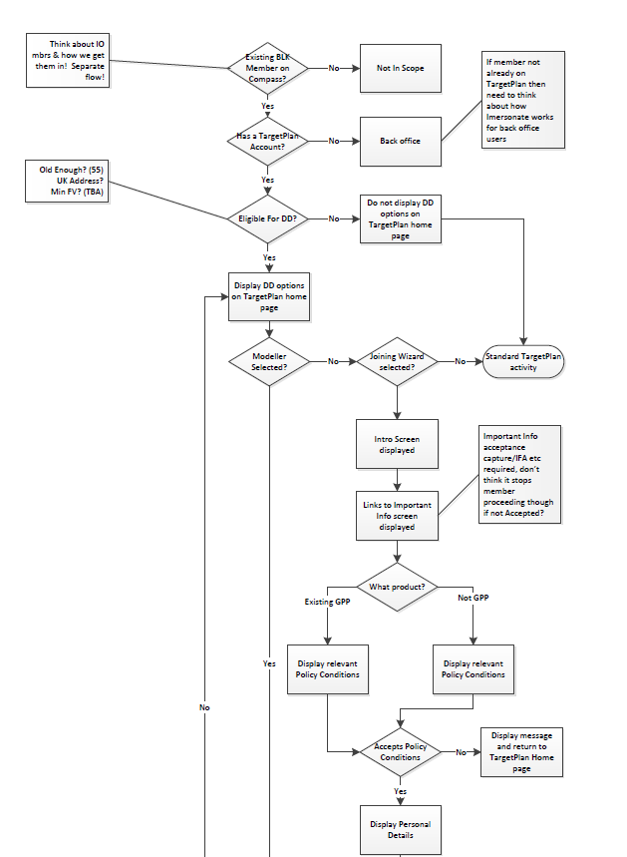

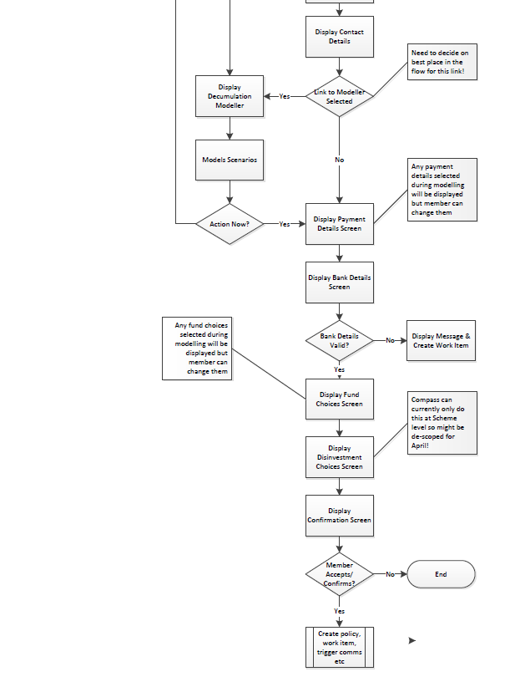

# Use Case Packages

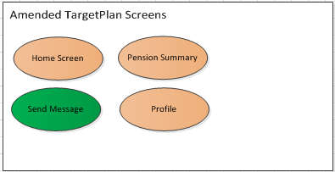

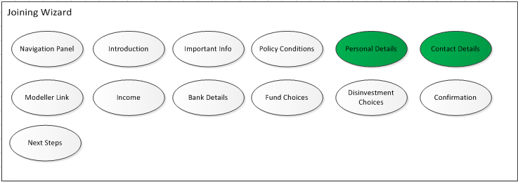

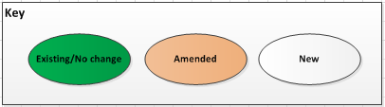

## Use Case Diagram – Amended TargetPlan Screens

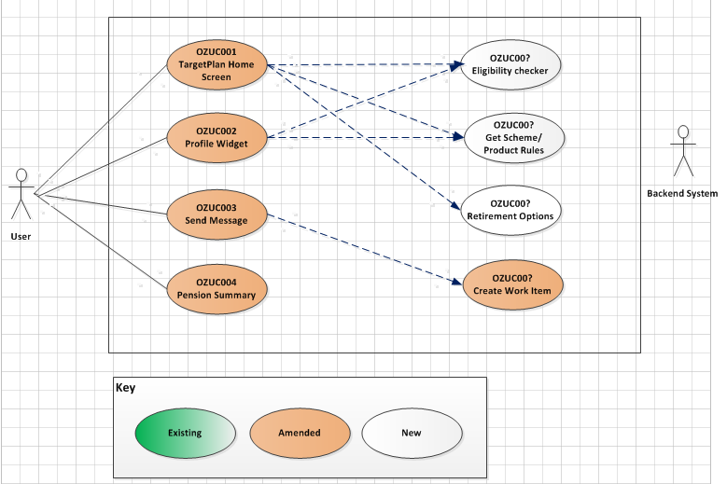

### OZUC001 – TargetPlan Home Page

|  |  |
| --- | --- |
| **Use Case Reference OZUC001**  **TargetPlan Home Page** | |
| **Summary** | TargetPlan home screen is the screen that the member lands on post registration/login. This will need amending to support the BlackRock Retirement Income Account |
| **Actor** | Member |
| **Trigger** | Member wishing to join the BlackRock Retirement Income Account |
| **Pre- conditions** | The member has access to TargetPlan |
| **Post –conditions** | The member can select the options required |
| **Frequency** | Adhoc |
| **Basic Course of Action** | 1. Member logs in 2. The system checks to see if the account they are logging in as is a “Drawdown” account invoke *OZUC00? – Get Scheme/Product Rules* 3. The system displays the TargetPlan home page applicable for the type of account the member is logging in to 4. The member navigates to the screens etc required |
| **Alternate scenario extensions** |  |
| **Business Logic/ Rules/ Supplementary Info** | Account Type Checking  When a member registers for TargetPlan they have to specify the account number with which they want to register. This then becomes their primary account.  If the member has multiple accounts linked to their “person” record then TargetPlan is aware of this and displays an option for the member to <<Change Scheme>> and/or change which account is their primary account.  Therefore if the account the member uses to log in with or if they login with their email address the primary account is their BlackRock Retirement Income Account then the items displayed on the TargetPlan home page need to differ.  Standard Accumulation Account Items (where member is eligible to join BRIA)   * Standard Message Centre Widget * Standard Profile Widget * Pension Summary * Pension Statement * Contributions * Plan Information and Documents * Fund Comparison * Fund Choices * Standard Header * Standard Footer * **New – Central panel to replace myTarget pods**   + Pension Summary   + Retirement Income Planner   + Retirement Centre   + Retirement Options * **Amend – link to myTarget**   A link to the Retirement Income Planner is also required on the left hand navigation bar throughout the TargetPlan site.  BlackRock Retirement Income Account items:   * Standard Message Centre * **Amended Pension Summary** * Pension Statement * Plan Information and Documents * Fund Comparison * **New version of Fund Choices** * Standard Header   The following items are required:   * **New – Central panel to replace myTarget pods**   + Pension Summary   + Retirement Income Planner   + Retirement Centre   + Retirement Options * Income Details (this logically could replace Contributions) * Amend Profile Widget to have the following links invoke *OZUC00? – Profile Widget:*   + Disinvestment Choices   + Bank Details   + IFA Details   Image & Background  Currently the background canvas (prisms) can only be either the standard BlackRock grey prisms or a plain white background. If should be possible to enhance this to pick a background and image so it can be branded more towards an individual clients needs. |
| **Notes / Questions** | 1. Need to check with Nigel C as to how he will be setting up the BRIA in Compass so that the system knows how to recognize it. If it’s just another scheme then an additional flag will need adding to UEXT so we can tell it’s a Drawdown scheme. – Nigel has confirmed that he will be creating a new Compass product (prd code 83) 2. Is it all members or is it only BlackRock & AON members? Will this facility be available to Mobius Life? – Mike Porter has confirmed it is available to all providers 3. Need to look at the wording around this the home screen graphic – Zoe 4. Need to come up with a graphic to replace the myTarget graphic – see new screen shots below 5. Need a name for the decum modeller |
| **Includes Use Cases** |  |
| **Additional Information** |  |
| **Links to Bus Req Id** | OZ_RO_0003 |
| **Created By** | Sue Allwood |

#### Current TargetPlan Home Page screen shot (with myTarget)

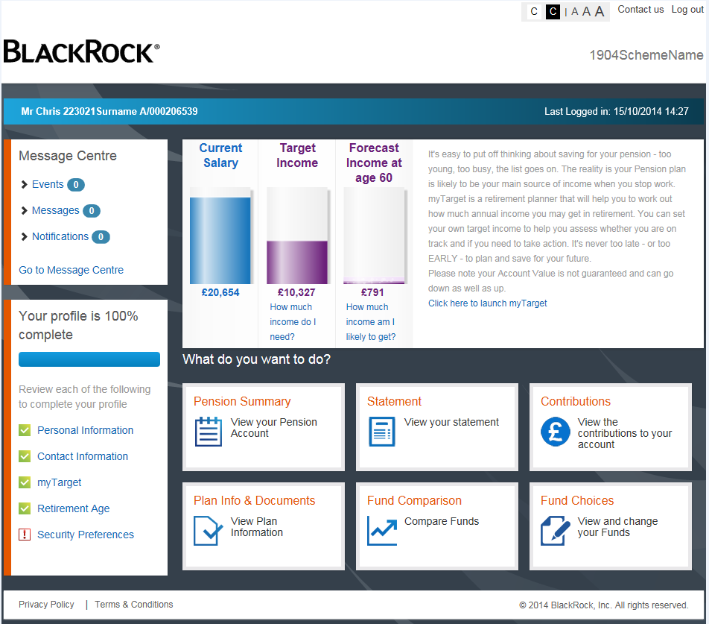

#### Current TargetPlan Home Page screen shot (without myTarget)

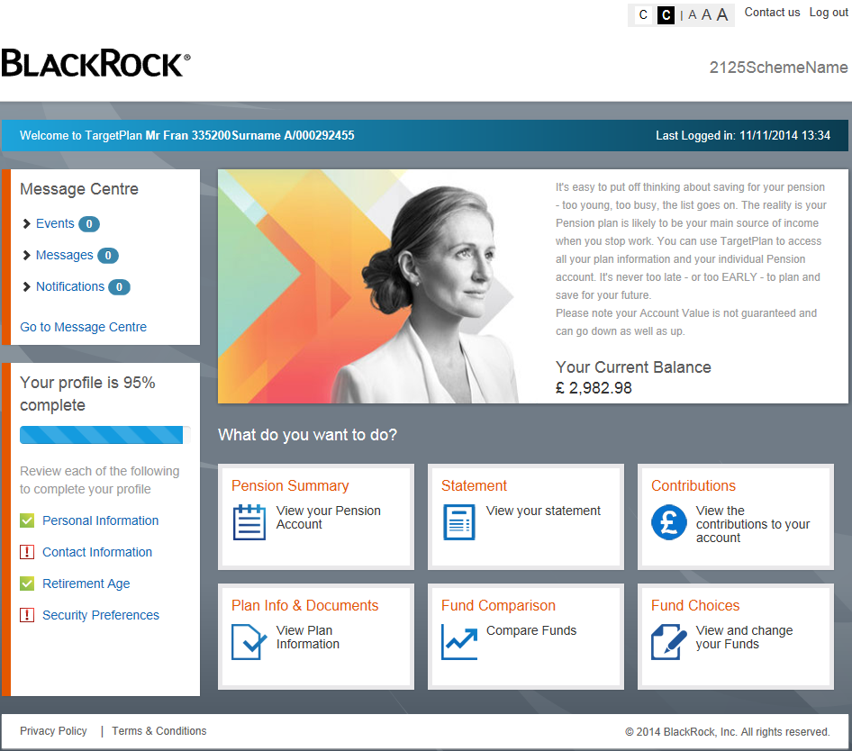

#### New TargetPlan Accumulation Home Page example screen shot

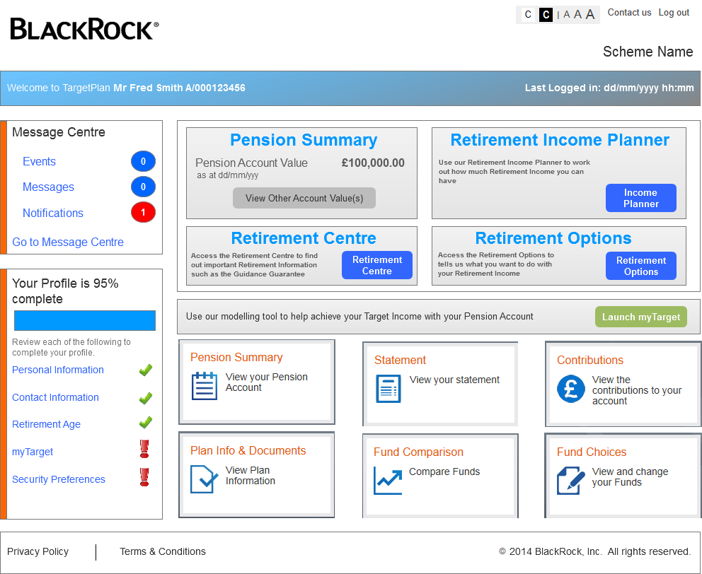

If the scheme isn’t myTarget enabled then the myTarget section in the middle should not be present.

#### New TargetPlan Decumulation Home Page example screen shot

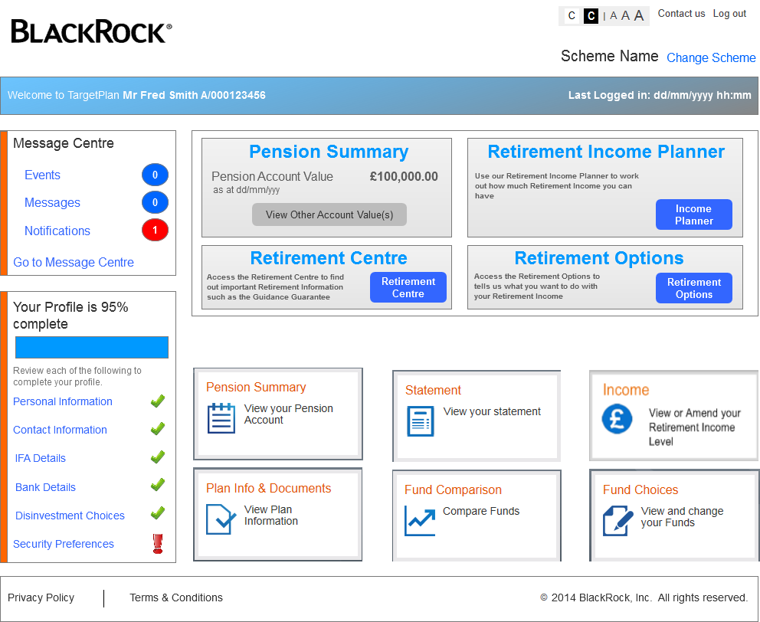

### OZUC002 - TargetPlan Profile Widget

|  |  |
| --- | --- |
| **Use Case Reference OZUC002**  **TargetPlan Profile Widget** | |
| **Summary** | Existing TargetPlan widget that is used by members to select specific “Profile type” screens |
| **Actor** | Member |
| **Trigger** | Member wishing to request one of the screens listed below |
| **Pre- conditions** | The member has access to TargetPlan |
| **Post –conditions** | The member can view the information in the screen selected |
| **Frequency** | Adhoc |
| **Basic Course of Action** | 1. Member logs in 2. The system displays the home screen (appropriate to the product invoke *OZUC00? – Get Scheme/Product Rules* 3. The system displays the items in the profile widget (appropriate to the product invoke *OZUC00? – Get Scheme/Product Rules* 4. The member selects the required item from the profile widget 5. The system displays the selected screen |
| **Alternate scenario extensions** |  |
| **Business Logic/ Rules/ Supplementary Info** | As well as the items changing on the home page the items displayed on the Profile Widget on the home page need to also change depending upon the type of account that the member has logged in to/selected invoke – *OZUC00? – Get Scheme/Product Rules*  The items that need displaying are:  Accumulation Account - no change   * Personal Information * Contact information * myTarget * Retirement Age * Security Preferences   Decumulation Account (joined BRIA)   * Personal Information * Contact information * Bank Details * IFA Details * Disinvestment Choices * Security Preferences   Launching Screens  When in the decumulation home screen if the member selects any of the items in the profile then instead of launching a “standalone” version of the screen it should launch the screen in the “joining wizard” this means that only one version of the screen is required to be built rather than a “wizard” version and a “standalone” version. |
| **Notes / Questions** |  |
| **Includes Use Cases** |  |
| **Additional Information** |  |
| **Links to Bus Req Id** | OZ_RO_0003 |
| **Created By** | Sue Allwood |

### Example of the Profile in Accumulation Mode

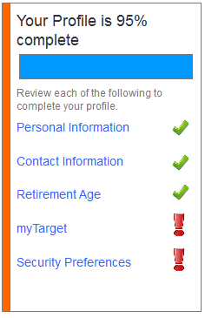

### Example of the Profile in Decumulation Mode

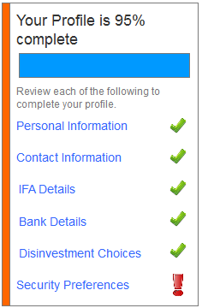

### OZUC003 – Send Message

|  |  |
| --- | --- |
| **Use Case Reference OZUC003**  **Send Message** | |
| **Summary** | Existing TargetPlan screen that is used by members to request specific details |
| **Actor** | Member |
| **Trigger** | Member wishing to request one of the items listed below |
| **Pre- conditions** | The member has access to TargetPlan |
| **Post –conditions** | The member can request the information required |
| **Frequency** | Adhoc |
| **Basic Course of Action** | 1. Member logs in 2. The member navigates to the Message Centre 3. The member selects <<Send Message>> 4. The member selects the category of message required 5. The member enters a title and some details and selects Submit 6. The system creates the appropriate work item for category requested 7. The Admin Centre deal with the request |
| **Alternate scenario extensions** |  |
| **Business Logic/ Rules/ Supplementary Info** | Send Message  Current functionality within TargetPlan enables members to select a “category” of message to send.  The categories map to work items that are created to enable the Admin Centre to deal with the member’s specific request.  The current list of categories are as follows:   * General * Complaint * Transfer In * Transfer Out * Illustration Request   This list needs to be amended to also add the following items:   * Benefit Statement Request * Annuity Request * Tax Free Lump Sum |
| **Notes / Questions** | 1. I assume request an annuity should map to the standard BAU Retirement Request work item? 2. What work item should the ben stat request map to? 3. Requirement OZ_RO_0027 asks for the ability for the member with request a benefit statement and to view a benefit statement. TargetPlan has a Pension Statement screen which shows all the sections available in a paper statement. I think the requirement actually wants the member to be able to see a physical copy of the paper statement online but this would a big piece of work for this phase and I think the requirement can be met in other ways. |
| **Includes Use Cases** |  |
| **Additional Information** | No TCS/screen changes required as the category listing comes from the back end system. |
| **Links to Bus Req Id** | OZ_RO_0011, OZ_RO_0026, OZ_RO_0027, OZ_RO_0035, OZ_RO_0036, |
| **Created By** | Sue Allwood |

#### TargetPlan Send Message Screen Shot

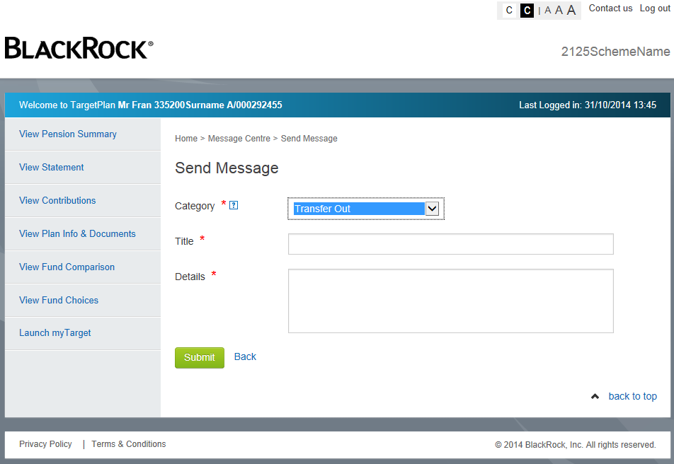

### OZUC004 – Pensions Summary

|  |  |
| --- | --- |
| **Use Case Reference OZUC004**  **Pension Summary** | |
| **Summary** | Existing TargetPlan screen that is used by members to summary details about their Pension |
| **Actor** | Member |
| **Trigger** | Member wishing to request one of the items listed below |
| **Pre- conditions** | The member has access to TargetPlan |
| **Post –conditions** | The member can view their Pension at a summary level |
| **Frequency** | Adhoc |
| **Basic Course of Action** | 1. Member logs in 2. The member navigates to the Pensions Summary screen 3. The system displays the correct details based upon the account the member is viewing. |
| **Alternate scenario extensions** |  |
| **Business Logic/ Rules/ Supplementary Info** | Pension Summary Overview  Pension Summary is an existing TargetPlan screen which will need changing to support Income Drawdown.  The screen is currently made up of the following sections:  **Pension Account Information**   * Current balance * Contribution Level * Frequency   **Other Pension Accounts (where applicable)**   * Value of any other pension accounts   **Retirement Age**   * Current TRA   **Current Investments**   * Split of Self Select/LifeStyle/LifePath * Any Money Type Grouping * Funds (link to factsheets) * AMC * Price * Units * Value * % of Account   See screen shot below for an example.   1. Retirement Age   When the member is in the BRIA scheme then the concept of Retirement Age is no longer applicable. Therefore if the account the member has accessed is the BRIA then do not display the Retirement Age Section invoke *OZUC00? – Get Scheme/Product Rules*.   1. Re-labelling of Pension Account Information   When in the accumulation account the Pension Account Information displayed is as follows:   * Your Account Value as at dd/mm/yyyy * Current value as a Percentage of Lifetime Allowance * Your Contribution * Your Employer’s Contribution (if applicable) * Your AVC (if applicable) * Last Contribution Paid * Frequency   There is also a button “View Contributions”  When in the drawdown account the Pension Account Information needs to display the following options:   * Your Account Value as at dd/mm/yyyy * Your Gross Retirement Income Level * Frequency * Last Income Payment Date * Next Income Payment Date   If an adhoc payment has been requested/made then it should also display:   * Adhoc Payment Amount * Last Adhoc Payment Date   The button should be changed to “View Income” and upon selecting this it should display the “Income” screen invoke *OZUC00? – Income Details* |
| **Notes / Questions** |  |
| **Includes Use Cases** |  |
| **Additional Information** |  |
| **Links to Bus Req Id** | OZ_RO_0010, OZ_RO_0018 |
| **Created By** | Sue Allwood |

#### Current Pension Summary Screen Shot example

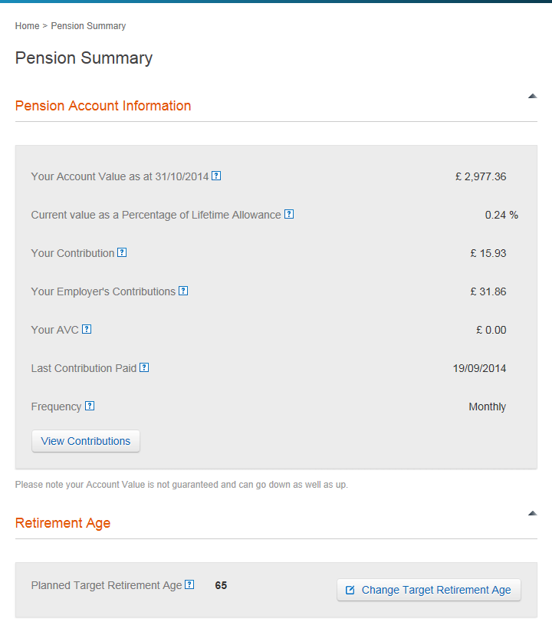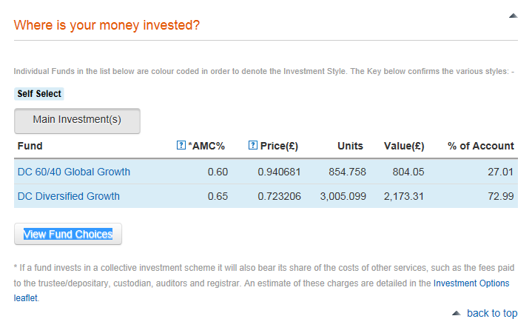

#### New Pension Summary Example Screen Shot

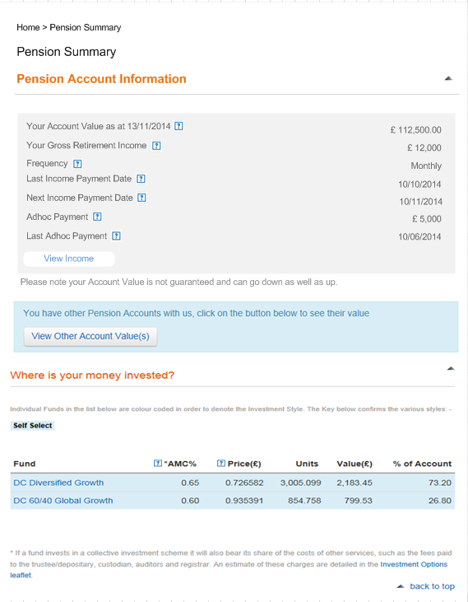

## Use Case Diagram – Joining Wizard

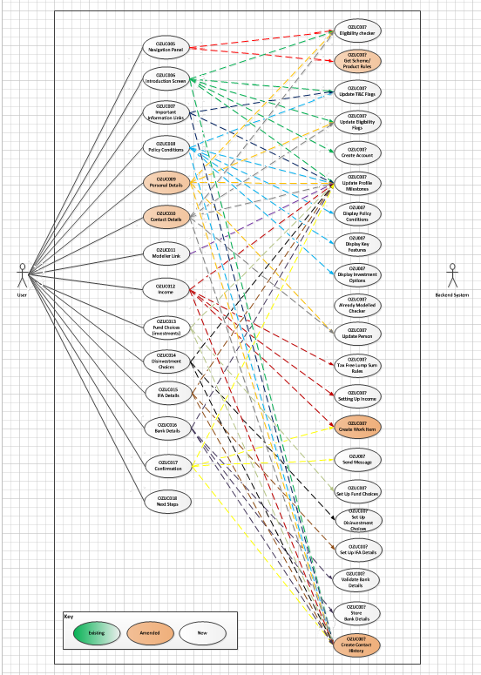

### OZUC005 – Navigation Panel

|  |  |
| --- | --- |
| **Use Case Reference OZUC005**  **Navigation Panel** | |
| **Summary** | A series of screens that have been linked together to allow the member to complete the data required to allow them to join the Income Drawdown scheme |
| **Actor** | Member |
| **Trigger** | Member wishing to join the BlackRock Retirement Income Account |
| **Pre- conditions** | The member has access to TargetPlan |
| **Post –conditions** | Member will completed required steps to join |
| **Frequency** | Adhoc |
| **Basic Course of Action** | 1. Member selects their Retirement Options 2. The system directs them to the Joining wizard for the valid options 3. The system takes the member to the 1st of the Joining screens 4. The member updates details and navigates through the other screens in the Joining suite of screens. The system will obtain the scheme/product rules when displaying the Joining suite of screens *invoke OCUC0?? – Get Scheme/Produce Rules* 5. The system updates the data items that can be STP or creates work item for those that can’t be STP invoke *‘OZUC00? – Create Work item’* 6. The member completes the Joining process 7. The system navigates the member to the TargetPlan Home page 8. The system updates the audit trail invoke *‘OZUC00? – Create Contact History*’ |
| **Alternate scenario extensions** | 5a. If the system can’t action the STP or create a work item for whatever reason display an appropriate message to the screen. |
| **Business Logic/ Rules/ Supplementary Info** | Online Joining Navigation Panel  Online joining is a suite of screens that need linking up to allow the member to easily navigate through them. A navigation panel should be present on each of the screens which shows the member which screen they are currently in, which screens they’ve already completed and which are remaining.  In addition there should be a link to the Retirement Income Planner and the Retirement Centre (which is part of Plan Information & Documents) to allow the member to model their Retirement Income or to view Retirement Education details at any time during the process.  The member should be able to leave and return to the process and carry on where they left off.  The navigation panel should show the screens grouped together logically as follows:   * Start Application (Introduction Screen) * Things your should know (Important Information)   + Policy Terms & Conditions * Personal & Contact Details (Personal Details)   + Contact Details * Plan your Income * Income & Fund Choices (Income)   + Fund Choices   + Disinvestment Choices * Confirmation (IFA Details)   + Bank Details   + Confirmation   + Next Steps   Online Joining Screen order  See section 6.2.1.1 below for details of the screen order. Some of the screens specified for Online Joining should also be available in standalone mode to allow the member to update details at a later date, the details of the screens are specified below. |
| **Notes / Questions** | 1. What shall we call this? |
| **Includes Use Cases** |  |
| **Additional Information** |  |
| **Links to Bus Req Id** | OZ_RO_0003, OZ_RO_0007, OZ_RO_0008, OZ_RO_0009, OZ_RO_0010, OZ_RO_0011, OZ_RO_0013, OZ_RO_0016, OZ_RO_0017, OZ_RO_0019, OZ_RO_0020, OZ_RO_0021, OZ_RO_0022, OZ_RO_0023, OZ_RO_0025 |
| **Created By** | Sue Allwood |

#### Joining Screen Order

|  |  |
| --- | --- |
| **Order** | **Screen** |
| 1 | Introduction |
| 2 | Important Information |
| 3 | Policy Terms & Conditions |
| 4 | Personal Details |
| 5 | Contact Details |
| 6 | Link to Modeller |
| 7 | Income |
| 8 | Investment choices |
| 9 | Disinvestment Choices |
| 10 | IFA Details |
| 11 | Bank Details |
| 12 | Confirmation |
| 13 | Next Steps |

#### Navigation Panel Example Screen Shot

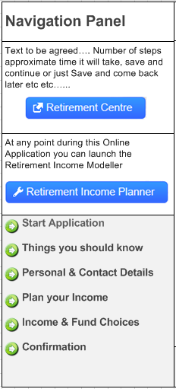

See each screen below for an example of what the Navigation Panel should look like on each screen.

### OZUC006 – Introduction Screen

|  |  |
| --- | --- |
| **Use Case Reference OZUC006**  **Introduction Screen** | |
| **Summary** | A screen the introduces the member to the BRIA joining process |
| **Actor** | Member |
| **Trigger** | Member wishing to join the BlackRock Retirement Income Account |
| **Pre- conditions** | The member has access to TargetPlan |
| **Post –conditions** | Member will understand the process of joining the BRIA |
| **Frequency** | Adhoc |
| **Basic Course of Action** | 1. The member selects Continue from the Retirement Options screen 2. The system takes the member to the Joining Introduction screen if they’ve selected a valid “BRIA” option 3. The member reviews the information contained on the screen 4. The member confirms their eligibility invoke ‘*OZUC00? – Update Eligibility Flags’* 5. The member selects the Continue button 6. The system displays the next screen in the “joining” suite of screens 7. The system updates the profile flags invoke ‘*OZUC00? – Update Profile Milestones’* 8. The system updates contact history *‘OZUC00? – Update Contact History’* |
| **Alternate scenario extensions** | 5a. If the member selects the Back button, take the user back to the TargetPlan home page  6a. Depending upon the option selected the system could create a work item and send a message to the member.  7a. If the member does not confirm their eligibility then the wizard is closed, no new account is created and the original TargetPlan home screen is displayed. |
| **Business Logic/ Rules/ Supplementary Info** | Introduction Screen  The screen contains content obtained from the back end content management system, which describes the BlackRock Retirement Income Account application process and the steps involved.  The screen should be made up of 2 sections:   1. Welcome 2. Eligibility   Upon accessing the screen only the “Welcome” section should be present.  This section contains the other eligibility items that the system cannot derive.  Currently the only item that needs confirming is:   * Do you hold a valid UK Bank Account?   The Continue button should be disabled until the member ticks the valid UK bank account option.  The member should be able to confirm this and the result should be stored in the back end system invoke *‘OZUC00? – Update Eligibility Flags’*. |
| **Notes / Questions** | 1. Need to define the text for this screen and any links that are needed - Zoe |
| **Includes Use Cases** |  |
| **Additional Information** | This joining introduction is only required whilst the member is in the joining process. Once they have finished the process and confirmed they wish to join this should no long be available for selection. |
| **Links to Bus Req Id** | OZ_RO_0009 |
| **Created By** | Sue Allwood |

#### Introduction Screen Properties

Text in {curly brackets} needs to come from the back end system as part of the Content or from a database field.

|  |  |  |  |  |  |  |  |
| --- | --- | --- | --- | --- | --- | --- | --- |
| **Screen Header Text** (i.e. any text before the data section) | | | | | | **Can tailoring apply?** | **Target** |
| **Online Application – Start Application** | | | | | | Y | tba |
| **Object** | **Text** | **Mandatory** | **Validation** | **Help Icon Applies** | **Help Icon Text** | n/a | n/a |
| Section Heading | **Welcome** | n/a | Standard Minimise/Maximise button | n/a | n/a | n/a | n/a |
| Section text | To be defined | n/a | Content from back end system | n/a | n/a | Y | Tba |
| Section Heading | **Eligibility** | n/a | Standard Minimise/Maximise button  Only display this section once the Drawdown tick box has been selected. | n/a | n/a | n/a | n/a |
| Tick Box | Do you hold a valid UK Bank Account? | n/a | This must be ticked to enable the member to continue. | N | n/a | N | n/a |
| Text | To be defined | n/a | Content from back end system | n/a | n/a | Y | Tba |
| Button | **Continue** | n/a | Disabled until the member has ticked the Valid UK bank account tick box.  Navigates to the first screen in the Online Joining suite of screens. | n/a | n/a | N | n/a |
| Button | **Save & Return Later** | n/a | Updates the profile flags for this member and exits |  |  |  |  |
| Button | **Back** | n/a | Standard “Are you sure?” message  Navigates the member back to the TargetPlan home page | n/a | n/a | N | n/a |
| Button | **Plan Info & Documents** | n/a | Link to the PI&D site for the scheme | n/a | n/a | N | n/a |
| **Screen Footer Text** (i.e. any text after the data section | | | | | | n/a | n/a |
| n/a | | | | | | Y | tba |

### Joining – Introduction Example Screen Shot

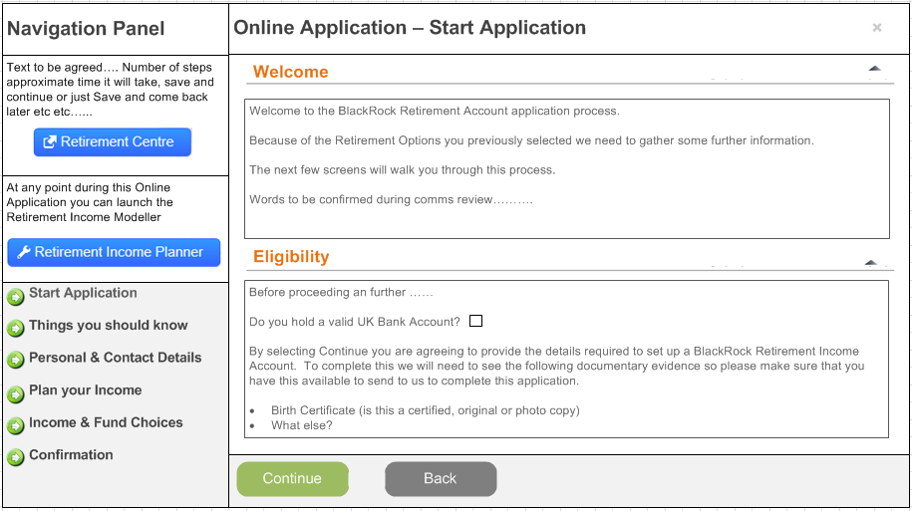

### OZUC007 – Important Information Links

|  |  |
| --- | --- |
| **Use Case Reference OZUC007**  **Important Information Links** | |
| **Summary** | A screen that displays details of the important information that the member has to review and acknowledge before proceeding with the application |
| **Actor** | Member |
| **Trigger** | Member wishing to join the BlackRock Retirement Income Account |
| **Pre- conditions** | The member has access to TargetPlan |
| **Post –conditions** | Member will have read/acknowledged the items required to join the BRIA |
| **Frequency** | Adhoc |
| **Basic Course of Action** | 1. The member selects continue from the previous screen in the “joining” suite of screens 2. The system displays the Important Information screen 3. The member reviews the important information and confirms that they have read it. 4. The system captures the date, time and version of each of the items that the member has acknowledged invoke ‘*OZUC00? – Update T&C Flags*’ 5. The member selects the Continue button 6. The system displays the next screen in the “joining” suite of screens 7. The system updates the profile flags invoke ‘*OZUC00? – Update Profile Milestones’* 8. The system updates contact history *‘OZUC00? – Update Contact History’* |
| **Alternate scenario extensions** | 7a. If the member does not acknowledge each of the required items do not allow them to continue with the application and display an appropriate message. |
| **Business Logic/ Rules/ Supplementary Info** | Online Joining Important Information Screen  The screen contains content obtained from the back end content management system (type webpart), which describes the important information that the member has to acknowledge before proceeding with the application.  The items required are:   * Guidance Guarantee – this is likely to be a link to a URL. * Money Purchase Annual Allowance notification   Guidance Guarantee  The member needs to acknowledge that they have read and understood the details in the Guidance Guarantee. The system needs to store the date, time and version (or URL) of the Guidance Guarantee that the member acknowledged invoke *‘OZUC00? – Update T&C Flags’*  Money Purchase Annual Allowance  The member needs to acknowledge that they have read and understood the effect of the Money Purchase Annual Allowance if they choose to proceed with their BRIA application. The system needs to store the date, time and version of the Money Purchase Annual Allowance that the member acknowledged invoke *‘OZUC00? – Update T&C Flags’*  If the member selects Save and Return after confirming these options but doesn’t return within a specified time period (to be agreed) then upon re-accessing TargetPlan the member should be returned to this step to re-acknowledge the items on this screen. |
| **Notes / Questions** | 1. Need to define the text for this screen and any links that are needed 2. Does a version number need storing for these documents? 3. If the details change do we need to re-present them to the member and get them to reconfirm or it is a one time review and capture? |
| **Includes Use Cases** |  |
| **Additional Information** | Once the member has joined then it is assumed that they will be able to access this information from the Plan Information & Documents site or the Retirement Centre. |
| **Links to Bus Req Id** | OZ_RO_0013, OZ_RO_0019 |
| **Created By** | Sue Allwood |

#### Important Information Screen Properties

Text in {curly brackets} needs to come from the back end system as part of the Content or from a database field.

|  |  |  |  |  |  |  |  |
| --- | --- | --- | --- | --- | --- | --- | --- |
| **Screen Header Text** (i.e. any text before the data section) | | | | | | **Can tailoring apply?** | **Target** |
| **Important Information**  To be defined | | | | | | Y | tba |
| **Object** | **Text** | **Mandatory** | **Validation** | **Help Icon Applies** | **Help Icon Text** | n/a | n/a |
| Section Heading | **Guidance Guarantee** | n/a | Standard Minimise/Maximise button | N | n/a | n/a | n/a |
| Section Text | To be defined | n/a | Content from back end content management system | N | n/a | n/a | n/a |
| Tick Box | **Guidance Guarantee acknowledged (to be defined)** | Y | Must be selected to continue. If the member does not select it they cannot continue with their application. | Y | To be defined | Y | tba |
| Section Heading | **Money Purchase Annual Allowance** | n/a | Standard Minimise/Maximise button | N | n/a | n/a | n/a |
| Section Text | To be defined | n/a | Content from back end content management system | N | n/a | n/a | n/a |
| Tick Box | **Money Purchase Annual Allowance acknowledged (to be defined)** | Y | Must be selected to continue. If the member does not select it they cannot continue with their application. | Y |  |  |  |
| Button | **Continue** | n/a | Navigates to the next screen in the “joining” suite of screens. | n/a | n/a | N | n/a |
| Button | **Save & Return Later** | n/a | Updates the profile flags for this member and exits |  |  |  |  |
| Button | **Back** | n/a | Standard “Are you sure?” message  Navigates the member back to the drawdown TargetPlan home page. | n/a | n/a | N | n/a |
| Button | **Plan Info & Documents** | n/a | Link to the PI&D site for the scheme | n/a | n/a | N | n/a |
| **Screen Footer Text** (i.e. any text after the data section | | | | | | n/a | n/a |
| n/a | | | | | | Y | tba |

#### Important Information Example Screen Shot

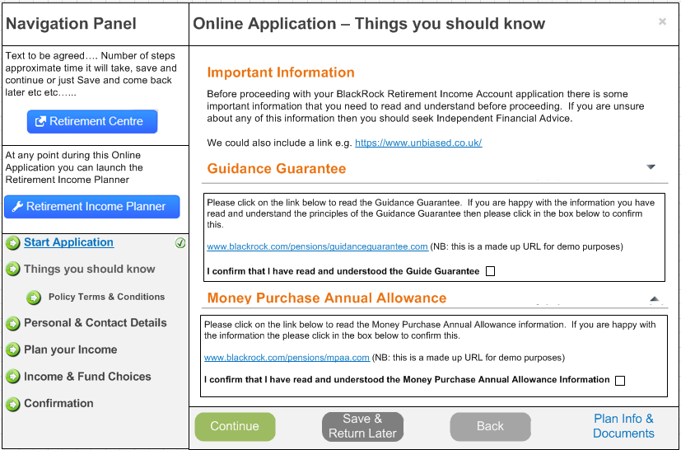

### OZUC008 – Policy Conditions

|  |  |
| --- | --- |
| **Use Case Reference OZUC008**  **Policy Conditions** | |
| **Summary** | A screen the displays details of the policy conditions that the member has to review and sign up to before proceeding with the application |
| **Actor** | Member |
| **Trigger** | Member wishing to join the BlackRock Retirement Income Account |
| **Pre- conditions** | The member has access to TargetPlan |
| **Post –conditions** | Member will have read/acknowledged the items required to join the BRIA |
| **Frequency** | Adhoc |
| **Basic Course of Action** | 1. The member selects the Continue button from the previous screen in the “joining” suite of screens 2. The system displays the Policy Conditions screen with the Policy Conditions section expanded invoke *‘OZUC00? – Display Policy Conditions’* 3. The member reviews the Policy Conditions and Accepts 4. The system captures the date, time and version of the policy conditions accepted them invoke *‘OZUC00? – Update T&C Flags’* 5. The system minimizes the Policy Conditions section and expands the Key Features section invoke ‘*OZUC00? – Display Key Features’* 6. The member reviews the Key Features and Accepts 7. The system captures the date, time and version of the key features accepted them invoke *‘OZUC00? – Update T&C Flags’* 8. The system minimizes the Key Features section and expands the Investment Options section invoke ‘*OZUC00? – Display Investment Options’* 9. The member reviews the Investment Options and Accepts 10. The system captures the date, time and version of the Investment Options accepted them invoke *‘OZUC00? – Update T&C Flags’* 11. The member selects the Continue button 12. The system displays the next screen in the “joining” suite of screens 13. The system updates the profile flags invoke ‘*OZUC00? – Update Profile Milestones’* |
| **Alternate scenario extensions** | 3a. 6a, 9a. If the member does not Accept the policy conditions, the key features or the investment options, the fact that they Declined should be recorded along with the date, time and version invoke *‘OZUC00? – Update T&C Flags’*. The system should not allow them to continue with the application and display an appropriate message. |
| **Business Logic/ Rules/ Supplementary Info** | Policy Terms & Conditions  The screen contains content obtained from the back end content management system (type web part), which describes the following items that the member has to Accept or Decline before proceeding with the application.   * Policy Terms and Conditions * Key Features * Investment Options   For each item the member has to be able to Accept/Decline and that needs capturing as follows:   * Accept or Decline * Document Type (may or may not be required depending upon how many items need accepting) * Date * Time * Version   The member should also be given the opportunity to download the each of the items so they can be saved locally or request a copy to be emailed to their primary email address invoke ‘*OZUC00? – Email Documents*’.  Policy Terms and Conditions  If the member selects Accepts the Policy Terms and Conditions, the system should automatically display the next section of the screen (Key Features).  If the member declines the system should display a Confirmation screen to the member and if they confirm again that they do not accept then the member should be returned to the TargetPlan Home screen.  Key Features  This section should only be expanded once the member has accepted the Policy Terms and Conditions.  If the member selects Accepts the Key Features, the system should automatically display the next section of the screen (Investment Options).  If the member declines the system should display a Confirmation screen to the member and if they confirm again that they do not accept then the member should be returned to the TargetPlan Home screen.  Investment Options  This section should only be expanded once the member has accepted the Key Features.  If the member selects Accepts the Investment Options, the system should automatically enable the Continue button.  If the member declines the system should display a Confirmation screen to the member and if they confirm again that they do not accept then the member should be returned to the TargetPlan Home screen.  If the member selects Save and Return after confirming these options but doesn’t return within a specified time period (to be agreed) then upon re-accessing TargetPlan the member should be returned to this step to re-acknowledge the items on this screen. |
| **Notes / Questions** | 1. Need to define the text for this screen and any links that are needed 2. Once the member has joined do these documents only live in PI&D? 3. If the versions of these documents change do we need to get the member to re-accept them? 4. Transfer Declaration will be added to the pack that is sent out rather than be an option on the screen |
| **Includes Use Cases** |  |
| **Additional Information** | Once the member has joined then it is assumed that they will be able to access this information from the Plan Information & Documents |
| **Links to Bus Req Id** | OZ_RO_0016 |
| **Created By** | Sue Allwood |

#### Online Application Policy Conditions Screen Properties

Text in {curly brackets} needs to come from the back end system as part of the Content or from a database field.

|  |  |  |  |  |  |  |  |
| --- | --- | --- | --- | --- | --- | --- | --- |
| **Screen Header Text** (i.e. any text before the data section) | | | | | | **Can tailoring apply?** | **Target** |
| **Online Application Policy Conditions** | | | | | | Y | tba |
| **Object** | **Text** | **Mandatory** | **Validation** | **Help Icon Applies** | **Help Icon Text** | n/a | n/a |
| Section Heading | **Policy Terms and Conditions** | n/a | Standard Minimise/Maximise button | N | n/a | n/a | n/a |
| Icon | PDF | n/a | If selected download the Policy Terms & Conditions to PDF | N | n/a |  |  |
| Section Text | To be defined | n/a | Content from back end content management system | N | n/a | n/a | n/a |
| Tick Box | **I confirm that I have read and accept the Policy Terms and Conditions** | Y | Must be selected to continue. If the member does not select it they cannot continue with their application. | Y | To be defined | Y | tba |
| Section Heading | **Key Features** | n/a | Standard Minimise/Maximise button | N | n/a | n/a | n/a |
| Icon | PDF | n/a | If selected download the Key Features to PDF | N | n/a |  |  |
| Section Text | To be defined | n/a | Content from back end content management system | N | n/a | n/a | n/a |
| Tick Box | **I confirm that I have read and accept the Key Features** | Y | Must be selected to continue. If the member does not select it they cannot continue with their application. | Y | To be defined | Y | tba |
| Section Heading | **Your Investment Options** | n/a | Standard Minimise/Maximise button | N | n/a | n/a | n/a |
| Icon | PDF | n/a | If selected download the Investment Options to PDF | N | n/a |  |  |
| Section Text | To be defined | n/a | Content from back end content management system | N | n/a | n/a | n/a |
| Tick Box | **I confirm that I have read and accept the Investment options available to me** | Y | Must be selected to continue. If the member does not select it they cannot continue with their application. | Y | To be defined | Y | tba |
| Button | **Continue** | n/a | Navigates to the next screen in the “joining” suite of screens. | n/a | n/a | N | n/a |
| Button | **Save & Return Later** | n/a | Updates the profile flags for this member and exits |  |  |  |  |
| Button | **Back** | n/a | Standard “Are you sure?” message  Navigates the member back to the drawdown TargetPlan home page. | n/a | n/a | N | n/a |
| Button | **Plan Info & Documents** | n/a | Link to the PI&D site for the scheme | n/a | n/a | N | n/a |
| **Screen Footer Text** (i.e. any text after the data section | | | | | | n/a | n/a |
| n/a | | | | | | Y | tba |

#### Policy Terms and Conditions Example Screen Shot

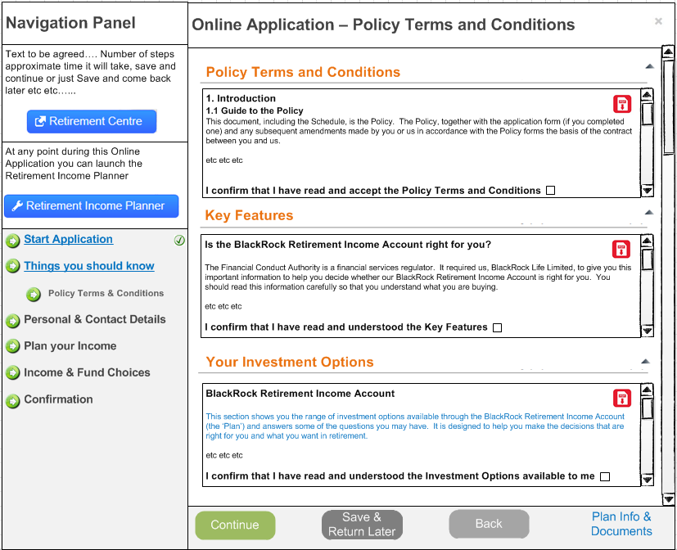

### OZUC009 – View/Change Personal Details

|  |  |
| --- | --- |
| **Use Case Reference OZUC009**  **View/Change Personal Details** | |
| **Summary** | Screen which enables the member to view or change their personal details as part of the online joining suite of screens. |
| **Actor** | Member |
| **Trigger** | Member wishing to join the BlackRock Retirement Income Account |
| **Pre- conditions** | The member has access to TargetPlan |
| **Post –conditions** | Member can view or update their personal details |
| **Frequency** | Adhoc |
| **Basic Course of Action** | 1. The member selects continue from the previous screen in the “joining” suite of screens 2. The system displays the <<Personal Details>> page 3. The member views their current personal details 4. The Member chooses to change their personal 5. The system displays an appropriate message on the screen 6. The system directly updates the back office systems where applicable details invoke ‘*OZUC00? – Update Person’* 7. The system create/updates work items ‘*OZUC00? – Create Work Item*’ and the audit trail invoke *‘OZUC00? – Create Contact History’’* 8. The system checks that the member is still eligible invoke ‘*OZUC00? – Eligibility Checker’* 9. The system updates the Eligibility flags invoke ‘*OZUC00? – Update Eligibility Flags*’ 10. The system updates the profile flags invoke ‘*OZUC00? – Update Profile Flags’* |
| **Alternate scenario extensions** | 8a. If the member is no longer eligible as a result of any changes made then a message should be displayed advising the member. Should a work item be created too? |
| **Business Logic/ Rules/ Supplementary Info** | Data Items  The system should display the current data for the following items:   * Title * First Name * Middle Name * Last Name * Date of Birth * Marital Status * NI Number (view only)   Change Personal Details  If the scheme rules invoke *‘OZUC00? – Get Scheme/Product Rules’* allow members to update their Personal Details then there should be an option available to the member which allows them to change their details. Upon selecting this option the screen should change from view only mode to edit mode. If the scheme does not allow Personal details to be changed then this option should not be present.  If any of the following data items are updated, display a message on the screen advising that we require documentary evidence before we can process the change.   * Last Name * Date of Birth   Direct Updates (STP)  If any of the following data items are updated then the back end system should be updated directly:   * Title * First Name * Middle Name * Marital Status   If any of these items are changed along with the items listed in the work item section then they should be added to the work item rather than being updated directly.  e.g. If the title is changed on its own then it’s STP. If the title and the surname are changed, display a message.  Audit Trail  All direct updates should create a record in the audit trail - invoke *‘OZUC00? – Create Contact History record’* |
| **Notes / Questions** |  |
| **Includes Use Cases** |  |
| **Additional Information** | No change from existing screen required as far as the fields etc., but this screen needs pulling into the “Joining” suite of screens to enable members to review the personal details and update if required.  It also needs to call the “Eligibility” checker if any data has changed and update the joining profile flags. |
| **Links to Bus Req Id** | n/a |
| **Created By** | Sue Allwood |

#### Personal Details Example Screen Shot

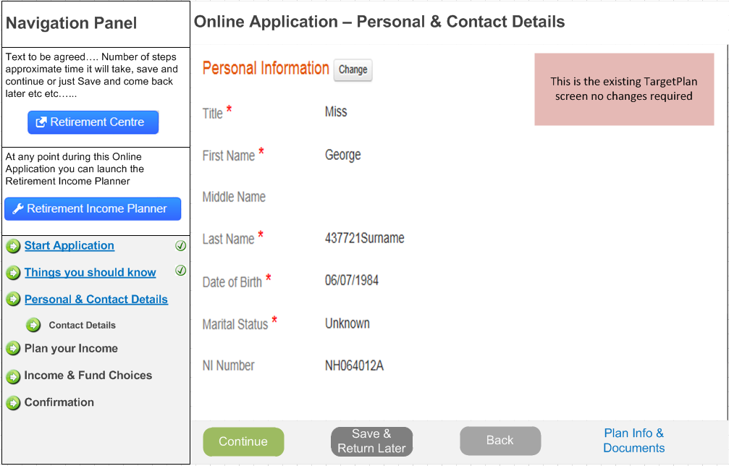

### OZUC010 – View/Change Contact Details

|  |  |
| --- | --- |
| **Use Case Reference OZUC010**  **View/Change Contact Details** | |
| **Summary** | Screen which enables the member to view or change their contact details |
| **Actor** | Member |
| **Trigger** | Member wishing to join the BlackRock Retirement Income Account |
| **Pre- conditions** | The member has access to TargetPlan |
| **Post –conditions** | Member can view or update their contact details |
| **Frequency** | Adhoc |
| **Basic Course of Action** | 1. The member selects continue from the previous screen in the “joining” suite of screens 2. The system displays the <<Contact Details>> page 3. The member views their current contact details 4. The member chooses to change their contact details 5. The system displays an appropriate message on the screen 6. The system directly updates the back office systems where applicable invoke *‘OZUC00? – Update Person’* 7. The system updates the audit trail – invoke ‘*OZUC00? – Create Contact History’* 8. The system checks that the member is still eligible invoke ‘*OZUC00? – Eligibility Checker’* 9. The system updates the eligibility flags invoke ‘*OZUC00? – Update Eligibility Flags’* 10. The system updates the profile flags invoke ‘*OZUC00? – Update Profile Milestones’* |
| **Alternate scenario extensions** | 8a. If the member is no longer eligible as a result of any changes made then a message should be displayed advising the member. Should a work item be created too? |
| **Business Logic/ Rules/ Supplementary Info** | Data Items  The system should display the current data for the following items:   * Address (lines 1 to 3); * City * County * Country * Post Code; * Home Phone Number; * Mobile Phone Number; * Work Phone Number; * Home e-Mail Address; * Primary Indictor * Email address used for Indicator –Contact Purposes * Work Email Address * Primary Indicator * Email address used for Indicator –Contact Purposes   Change Contact Details  If the scheme rules allow members to update their Contact Details then there should be an option available to the member which allows them to change their details. Upon selecting this option the screen should change from view only mode to edit mode. If the scheme does not allow Contact details to be changed then this option should not be present where the members account status is “Active”. For any other account statuses even if the scheme does not allow Contact Details to be updated the system should still allow the details to be updated as the member is effectively no longer in the scheme so it should be possible to keep their contact details up to date.  Address Look Up  The system should be integrated with an address lookup system called “Postcode Anywhere” the data entry fields for the address should therefore be configured accordingly.    Direct Updates (STP)  If any of the following data items are updated then the back end system should be updated directly:   * Address Lines 1 –3 * County * Country * Post Code * Home Phone Number; * Mobile Phone Number; * Work Phone Number; * Home e-Mail Address; * Primary Indicator? * Email address used for Indicator –Contact Purposes * Work Email Address; * Primary Indicator * Email address used for Indicator –Contact Purposes   Work Item Creation  Where any of the address items or postcode has changed also create a work item to enable the back office to send the appropriate letters – invoke ‘*OZUC00? – Create Work Item’*  Email Address Changes  At least one of the Email address must have the Primary Email Indicator set which indicates that this is the UserID.  Either of the Email Address could be set to “Used for Contact”  If the email address which is marked as the primary email address is changed, then a message should be displayed on the screen advising the member that this is their User ID and this will also be changed as a result. If the primary indicator is changed then this should also result in a message being displayed and the user id should be updated to the email address linked to the primary indicator.    Audit Trail  All changes whether a work item or a direct update should create a record in the audit trail - invoke *‘OZUC00? – Create Contact History’* |
| **Notes / Questions** |  |
| **Includes Use Cases** |  |
| **Additional Information** | No change from existing screen required as far as the fields etc., but this screen needs pulling into the “Joining” suite of screens to enable members to review the contact details and update if required.  It also needs to call the “Eligibility” checker if any data has changed and update the joining profile flags. |
| **Links to Bus Req Id** | n/a |
| **Created By** | Sue Allwood |

#### Contact Details Example Screen Shot

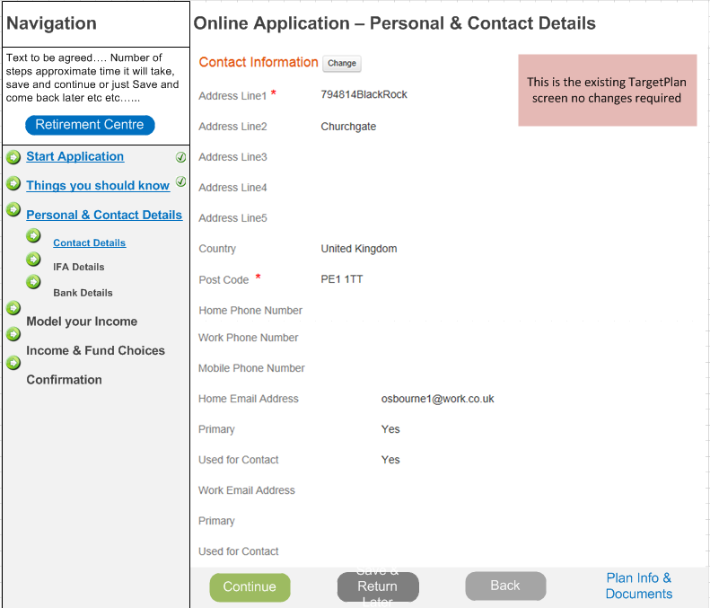

### OZUC011 – Modeller Link

|  |  |
| --- | --- |
| **Use Case Reference OZUC011**  **Modeller Link** | |
| **Summary** | A screen/link that enables the member to link out to the decumulation modeler as part of the joining process |
| **Actor** | Member |
| **Trigger** | Member wishing to join the BlackRock Retirement Income Account |
| **Pre- conditions** | The member has access to TargetPlan |
| **Post –conditions** | Member will have used the modeler to help define their Drawdown Income/options |
| **Frequency** | Adhoc |
| **Basic Course of Action** | 1. The member selects continue from the previous screen in the “joining” suite of screens 2. The system checks to see if the member has previously modelled invoke ‘*OZUC00? – Modeller Feedback*’ 3. The system displays a screen to enable the member to navigate to the <<Decumulation Modeller>> (different options displayed if member has previously modelled) 4. The member selects the <<Decumulation Modeller>> link 5. The system launches the <<Decumulation Modeller>> 6. The system passes any data known about the member and required by the modeler to the modeler (this is defined in a separate functional spec) 7. The member uses to modeller to determine their Drawdown options/income 8. The member comes out of the modeller by selecting an <<ACTION NOW >> option 9. The modeller passes any data required by the joining process back to the calling system 10. The system displays the next screen in the “joining” suite of screens 11. The system updates the profile flags invoke ‘*OZUC00? – Update Profile Milestones’* |
| **Alternate scenario extensions** | 7a. If the user accesses the modeller but does not select the <<ACTION NOW>> option then no data will be returned to the calling system. |
| **Business Logic/ Rules/ Supplementary Info** | 2. Previously Modelled  If the system detects that the member has previously modelled then the version of the screen that is displayed needs to change as follows:   * Continue using your previously modelled selections * Launch the Retirement Income Modeller to review your previous selections * Launch the Retirement Income Modeller with no previous selections   If the modeller hasn’t previously been used then the screen should just offer the member the following options:   * Click here to launch the Retirement Income Modeller * Continue   5. Data Items Required by the Modeller   * Current Age * Current Fund Value (this should be displayed on the TargetPlan Screen too) * Current TRA * Current Salary * Security token (details to be defined in technical stage) * What else?   Where the member has multiple pension accounts then each of the schemes that the member has a fund value in should be listed. TBA – analysis required to assess population of member to see if this is required for April.  8. Data Items Required by the Joining Process  Upon the user selecting Action Now, they should be returned to the TargetPlan Joining wizard at the correct next point <<Income>> and the following data from the modeller should be returned to and displayed in the correct fields:   * Drawdown Payment Amount (understood this is annual amount, therefore system will have to signpost this or divide down when member selects their payment frequency) * Fund Choice * Other Pension Amounts (is any other data being captured or required around this) * Annuity amount * Tax Free Cash amount * What else? – potentially need to display the other pension pots entered when modelling!   Keep Alive  The member could be in the modeller for longer that the standard TargetPlan time out of 9.5 minis, therefore the modeler needs to send TargetPlan a keep alive message. TargetPlan needs to receive this keep alive message and not time out whilst the member is actively using the modeler.  If the member does not use the modeller for > 10 mins then the keep alive messages should stop and therefore both applications should time out. The standard TargetPlan time out routine and screens should be displayed. |
| **Notes / Questions** | 1. What is the decumulation modeler going to be called? |
| **Includes Use Cases** |  |
| **Additional Information** | * Full Decumulation Modeller functionality is being defined in a separate Functional Specification. * Access to the Decumulation Modeller is required in standalone mode too. The details for this are defined in ‘*OZUC00? - ??’* * It is assumed that the decumulation modeller will be launched in a separate browser window. * Need to understand if we’ll be able to detect that the member has modelled or not! Assume for the time being that we will know! |
| **Links to Bus Req Id** | OZ_RO_0003, OZ_RO_0017 |
| **Created By** | Sue Allwood |

#### Link to Modeller Screen Properties (not previously modelled)

Text in {curly brackets} needs to come from the back end system as part of the Content or from a database field.

|  |  |  |  |  |  |  |  |
| --- | --- | --- | --- | --- | --- | --- | --- |
| **Screen Header Text** (i.e. any text before the data section) | | | | | | **Can tailoring apply?** | **Target** |
| **Launch Retirement Income Modeller**  Before completing the application process you need to decide what your income options are based on what you have now compared to what you need in retirement. If you already know this then click Continue below to skip this step. Else click on the link below to use our Retirement Income Modeller to help you decide on your Retirement Income Options. | | | | | | Y | tba |
| **Object** | **Text** | **Mandatory** | **Validation** | **Help Icon Applies** | **Help Icon Text** | n/a | n/a |
| Screen Text | Total Fund value Available for Retirement Income | n/a |  | Y | To be defined | N | n/a |
| Data Item | Fund Value | n/a | £nnn,nnn,nnn.00 | N | n/a | n/a | n/a |
| Screen Text | Your Total Fund Value is made up of the following: | n/a | Only present in the member has more than one pension account | N | n/a | n/a | n/a |
| Screen Text | Our records show that your have previously used the Retirement Income Modeller, would you like to: | n/a | n/a | N | n/a | n/a | n/a |
| Radio Button | Continue using your previously modelled selections | n/a | At least one of the radio buttons must be selected | Y | To be defined | n/a | n/a |
| Radio Button | Launch the Retirement Income Modeller to review your previous selections | n/a | At least one of the radio buttons must be selected | Y | To be defined | n/a | n/a |
| Radio Button | Launch the Retirement Income Modeller with no previous selections | n/a | At least one of the radio buttons must be selected | Y | To be defined | n/a | n/a |
| Button | **Continue** | n/a | Navigates to the next screen | n/a | n/a | N | n/a |
| Button | **Save & Return Later** | n/a | Updates the profile flags for this member and exits – should this invoke the standard log out routine? |  |  |  |  |
| Button | **Back** | n/a | Standard “Are you sure?” message  Navigates the member back to the previous screen | n/a | n/a | N | n/a |
| Button | **Plan Info & Documents** | n/a | Link to the PI&D site for the scheme | n/a | n/a | N | n/a |
| **Screen Footer Text** (i.e. any text after the data section | | | | | | n/a | n/a |
| n/a | | | | | | Y | tba |

#### Link to Modeller Screen Properties (previously modelled)

Text in {curly brackets} needs to come from the back end system as part of the Content or from a database field.

|  |  |  |  |  |  |  |  |
| --- | --- | --- | --- | --- | --- | --- | --- |
| **Screen Header Text** (i.e. any text before the data section) | | | | | | **Can tailoring apply?** | **Target** |
| **Launch Retirement Income Modeller**  Before completing the application process you need to decide what your income options are based on what you have now compared to what you need in retirement. If you already know this then click Continue below to skip this step. Else click on the link below to use our Retirement Income Modeller to help you decide on your Retirement Income Options. | | | | | | Y | tba |
| **Object** | **Text** | **Mandatory** | **Validation** | **Help Icon Applies** | **Help Icon Text** | n/a | n/a |
| Screen Text | Total Fund value Available for Retirement Income | n/a |  | Y | To be defined | N | n/a |
| Data Item | Fund Value | n/a | £nnn,nnn,nnn.00 | N | n/a | n/a | n/a |
| Screen Text | Your Total Fund Value is made up of the following: | n/a | Only present in the member has more than one pension account | N | n/a | n/a | n/a |
| Screen Text | {Scheme name} {Account Number} | n/a | Only present in the member has more than one pension account  Repeat for each pension account the member has | N | n/a | n/a | n/a |
| Data Item | Fund Value | n/a | £nnn,nnn,nnn.00  Repeat for each pension account the member has | N | n/a | n/a | n/a |
| Screen Text | Click here to launch the Retirement Income Modeller | n/a | n/a | N | n/a | n/a | n/a |
| Button | **Continue** | n/a | Navigates to the next screen | n/a | n/a | N | n/a |
| Button | **Save & Return Later** | n/a | Updates the profile flags for this member and exits – should this invoke the standard log out routine? |  |  |  |  |
| Button | **Back** | n/a | Standard “Are you sure?” message  Navigates the member back to the previous screen | n/a | n/a | N | n/a |
| Button | **Plan Info & Documents** | n/a | Link to the PI&D site for the scheme | n/a | n/a | N | n/a |
| **Screen Footer Text** (i.e. any text after the data section | | | | | | n/a | n/a |
| n/a | | | | | | Y | tba |

#### Launch Modeller Example Screen Shot

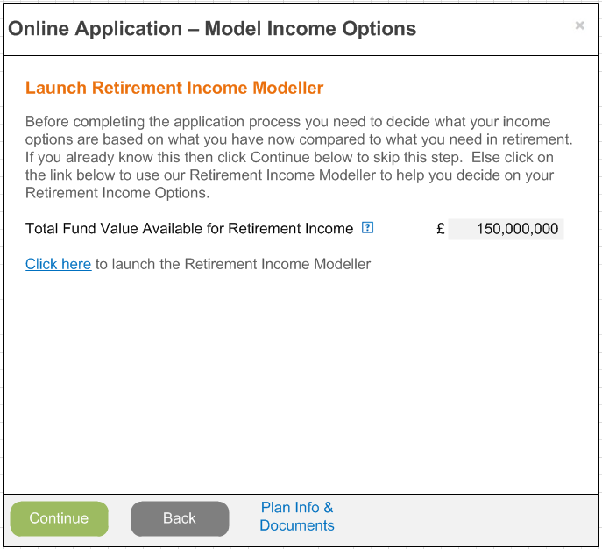

#### Launch Modeller Example Screen Shot (previously modelled)

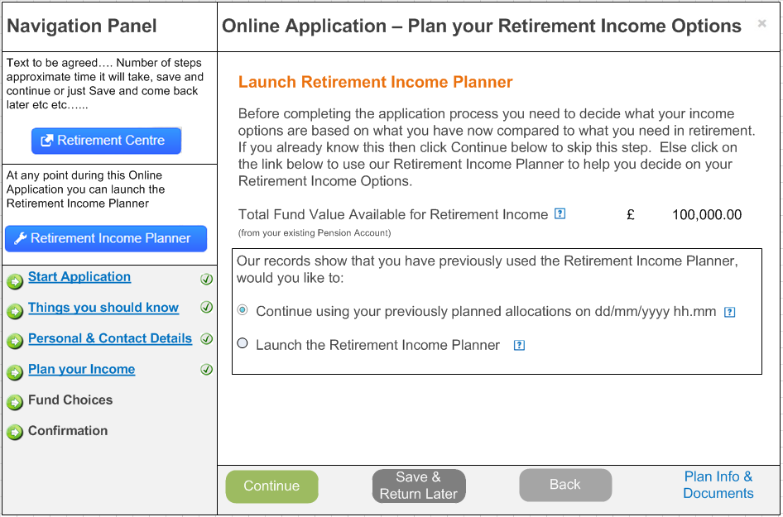

### OZUC012 – Income

|  |  |
| --- | --- |
| **Use Case Reference OZUC012**  **Income** | |
| **Summary** | A screen that enables the member to confirm the income details required |
| **Actor** | Member |
| **Trigger** | Member wishing to join the BlackRock Retirement Income Account |
| **Pre- conditions** | The member has access to TargetPlan |
| **Post –conditions** | Member will have defined their Drawdown Income/Options |
| **Frequency** | Adhoc |
| **Basic Course of Action** | 1. The member selects Continue from the <<previous screen>> 2. The system displays a screen to enable the member to confirm the income details they require from their drawdown account 3. The member reviews the data items required and amends any of the prepopulated data 4. The system updates the members account with the income details invoke *‘OZUC00? – Setting Up Income’* 5. The system creates any work items required invoke *‘OZUC00? – Create Work Item’* 6. The system displays the next screen in the “joining” suite of screens 7. The system updates the profile flags invoke ‘*OZUC00? – Update Profile Milestones’* 8. The system updates contact history *‘OZUC00? – Update Contact History’* |
| **Alternate scenario extensions** |  |
| **Business Logic/ Rules/ Supplementary Info** | It is recommend that this screen is an accordion style screen which enables the items required to be grouped together logically and later sections are minimsed until the member is ready to complete them.  Sections on this screen should be as follows:   * Fund Value * Initial Cash Withdrawal * Income Details * Annuity Details   Fund Value  This should show the total value that the member indicated they wanted to move into their “BRIA” on the Retirement Options screen.    Initial Cash Withdrawal  If the member requested any Cash via the retirement options screen then this should be populated in this section and the section should be automatically expanded  This section should have the following fields on it:   * £ Amount of Lump Sum. The member should be able to override this Amount if required.   Validation needs to be present to make sure that if the amount is overridden in this screen then it should not exceed to total amount carried forward from the Retirement Options Screen:  The maximum Lump Sum cannot exceed the Total Fund Value available, please adjust the amount accordingly.  Details on what the system needs to do with regard to the rules around the Tax Free lump sum payment is specified in *‘OZUC00?? – Tax Free Lump Sum Rules’*.  If the member has a status of “Enhanced Protection” and they request a Tax Free Lump sum then a work item should be created invoke *‘OZUC00? – Create Work Item’* and the following message should be displayed:  You have a protected lump sum, we will be in touch with your shortly to advise you of your options.  Income Details  If the member entered “Income” in the “Retirement Options” screen then this section should be maximized upon entry to the screen and any details entered in that screen should be carried forward. The member should be able to edit the details if required.  This section should have the following items present:   * Retirement Income Fund – the member should be able to enter £ amount. Validation should be present to make sure that the total entered in this field does not exceed the total fund value available – the lump sum amount entered. * Gross Income Amount. The system should display the amount entered in the retirement options screen. The member should be able to override this amount if required. Validation is required to ensure that the amount entered here does not exceed the Total Retirement Income Fund. * Payment Frequency (default Monthly) * Payment Increases (default none)   The Payment Frequency should have the following values:   * Monthly (default) * Quarterly * Half Yearly * Yearly   The Payment Increase Type should have the following items in it:   * None * Inflation (default) * Fixed (if fixed then another field should be displayed to allow the member to enter a % - range between 1 and 10 (to be defined)   If the member chooses something other than None the system needs to therefore calculate the annual increase to the payments. This will be done at the end of each tax year (i.e. 5th April)  Details on what the system needs to do with regard to setting up the income withdrawal amount is specified in *‘OZUC00?? – Setting Up Payments’*.  Annuity Details  As well as having a regular income from the drawdown product the member could also choose to have an Annuity. If the member selected an Annuity in the Retirement Options screen then this section should be expanded and the annuity details entered should be carried forward.    This section should have the following fields on it:   * Amount required to purchase an Annuity. Validation is required to make sure that if the member does amend this amount that it does not exceed the total fund value available – any Lump Sum – any income.   Whenever an annuity is requested the system should create a work item invoke *‘OZUC00? – Create Work Item’* to invoke the standard BAU annuity process. The following message should be displayed:  Your request has been submitted we will be in touch with you shortly……etc etc.  The system needs check that the total £ amount entered across all 3 sections does not exceed the Total Fund Value available for Retirement Income. |
| **Notes / Questions** |  |
| **Includes Use Cases** |  |
| **Additional Information** |  |
| **Links to Bus Req Id** | OZ_RO_0010, OZ_RO_0017, OZ_RO_0023, OZ_RO_0035 |
| **Created By** | Sue Allwood |

#### Income Details Screen Properties

Text in {curly brackets} needs to come from the back end system as part of the Content or from a database field.

|  |  |  |  |  |  |  |  |
| --- | --- | --- | --- | --- | --- | --- | --- |
| **Screen Header Text** (i.e. any text before the data section) | | | | | | **Can tailoring apply?** | **Target** |
| **Income Details** | | | | | | Y | tba |
| **Object** | **Text** | **Mandatory** | **Validation** | **Help Icon Applies** | **Help Icon Text** | n/a | n/a |
| Sub Heading | **Fund Value** | n/a | n/a | n/a | n/a | n/a | n/a |
| Field Label | Total Fund Value Available for Retirement Income | n/a | £nnn,nnn,nnn.00  View Only | Y | To be defined | n/a | n/a |
| Section Heading | **Initial Cash Withdrawal** | n/a | Standard minimise/maximize icon |  |  |  |  |
| Section Text | You told us that you would like the following Initial Cash Withdrawal: | n/a | n/a | n/a | n/a | N | n/a |
| Field Label | Lump Sum | n/a | £ amount  Slider linked to this field | Y | To be defined | N | n/a |
| On screen text | Please click here for more information about your Initial Cash options | n/a | n/a | N | n/a | N | n/a |
| Section Heading | **Income Details** | n/a | Standard minimise/maximize icon | n/a | n/a | n/a | n/a |
| Section Text | You told us that you would like the following Regular Income: | n/a | n/a | n/a | n/a | N | n/a |
| Field Label | Retirement Income Fund | Y | £ amount  Slider linked to this field | Y | To be defined | n/a | n/a |
| Field Label | Gross Income Amount | n/a | Mandatory if an Income Fund has been entered  £n,nnn,nnn.nn | Y | To be defined | n/a | n/a |
| Field Label | Taxable Income Element | N | View Only field that displays the taxable income based on the rules defined in the system. | Y | To be defined |  |  |
| Field Label | Non Taxable Income Element | N | View Only field that displays the non taxable income based on the rules defined in the system. | Y | To be defined |  |  |
| Pull Down List | Payment Frequency | N | Monthly - this is the default  Quarterly  Half yearly  Yearly | Y | To be defined | n/a | n/a |
| Pull Down List | Escalation | N | None  Inflation (default)  Fixed | Y | To be defined | n/a | n/a |
| Field Label | % | N | If fixed has been entered as an escalation type then display another field to enable the member to enter a % between 1 and 10 |  |  |  |  |
| Section Heading | **Annuity Details** | n/a | Standard minimise/maximize icon | n/a | n/a | n/a | n/a |
| Section Text | You told us that you would like the following Annuity | n/a | n/a | n/a | n/a | N | n/a |
| Field Label | Amount required to purchase an Annuity | n/a | % or £ amount  Slider linked to both fields | Y | To be defined | n/a | n/a |
| On screen text | Please click here for more information about your Annuity options | n/a | n/a | N | n/a | N | n/a |
| Button | **Continue** | n/a | Navigates to the next screen | n/a | n/a | N | n/a |
| Button | **Save & Return Later** | n/a | Updates the profile flags for this member and exits |  |  |  |  |
| Button | **Back** | n/a | Standard “Are you sure?” message  Navigates the member back to the previous screen | n/a | n/a | N | n/a |
| Button | **Plan Info & Documents** | n/a | Launches the PI&D site for the scheme | n/a | n/a | N | n/a |
| **Screen Footer Text** (i.e. any text after the data section | | | | | | n/a | n/a |
| n/a | | | | | | Y | tba |

#### Income Example Screen Shot (Cash & Drawdown)

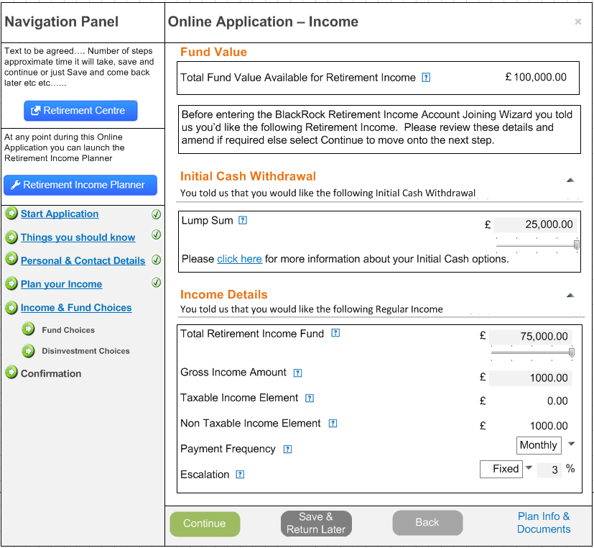

#### Income Example Screen Shot (Drawdown & Annuity)

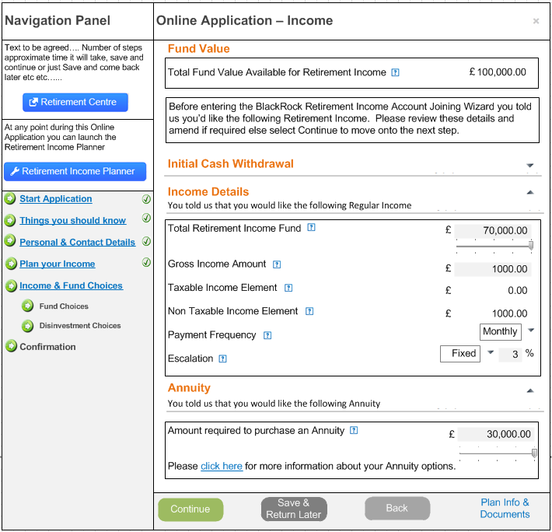

### OZUC013 – Joining Fund Choices Details

|  |  |
| --- | --- |
| **Use Case Reference OZUC013**  **Joining Fund Choices** | |
| **Summary** | A screen that enables the member select their fund choices for their BlackRock Retirement Income Account |
| **Actor** | Member |
| **Trigger** | Member wishing to join the BlackRock Retirement Income Account |
| **Pre- conditions** | The member has access to TargetPlan |
| **Post –conditions** | Member will have entered their fund choices |
| **Frequency** | Adhoc |
| **Basic Course of Action** | 1. The member selects Continue from the <<previous screen>> 2. The system displays a screen to enable the member to select their fund investment choices, with the default investment strategy already selected 3. The member leaves the default investment choice selected or selects an alternative based of the fund choice options defined on the scheme. 4. The system updates the members account with the fund choices details invoke *‘OZUC00? – Set Up Fund Choices’* 5. The system displays the next screen in the “joining” suite of screens 6. The system updates the profile flags invoke ‘*OZUC00? – Update Profile Milestones’* 7. The system updates contact history *‘OZUC00? – Update Contact History’* |
| **Alternate scenario extensions** |  |
| **Business Logic/ Rules/ Supplementary Info** | When a member is joining BRIA they need to be able to select the fund choices (investment strategy) that they’d like their Income Drawdown pot of money invested in.  The options available to a BRIA member are:   * LifePath (this is the default option) * Self Select   Under the list of options there should be a link to the PI&D list of funds screen (as per the existing screen).  As the member’s investment options are much simpler in drawdown than in accumulation it is recommended that a new version of the fund choices screen is built.  LifePath  Once in drawdown the member can invest in a LifePath fund. In decumulation the LifePath options are different to those in accumulation as the member has already reached/passed their Target Retirement Age so the link between TRA and LifePath fund is not required.  The assumption is at the time of writing that there will be one LifePath fund linked to the BRIA Scheme and it will be called LifePath Drawdown.  Upon accessing the Fund Choices screen whilst in the joining wizard the LifePath Drawdown fund should be automatically selected as it is the Default investment option. The LifePath drawdown fund description should also be a hyperlink to the fund factsheet.  If the member wants to select the LifePath Drawdown fund then no further options are required and the member should select Continue to move onto the next screen in the joining suite of screens.  Self-Select  Alternatively the member can select their own fund choices. In this scenario the member should select the “Pick my own” option.  When this option is selected the screen should then display all the self-select funds linked to the scheme (currently this is thought to be the core set of BlackRock funds which will be about 90 funds – it is unknown at present whether of these 90 some will be marked as “Core” funds).  If core funds are present then only the core funds should be displayed initially and the member should be given the option to see all the funds as per the current screen functionality.  The following columns should be displayed:   * Fund (the fund name should also be a link to the fund factsheet) * AMC% * %   The member must enter the % against each fund that they would like to be invested in. The total % must equal 100%, the Continue button should be disabled if the total does not equal 100%.  Once the member has made their Fund Choices the investment group and election details need creating invoke ‘*OZUC00? – Set Up Fund Choices*’ |
| **Notes / Questions** | 1. Will the scheme have core/non core funds? 2. Will the scheme just have 1 Investment Group? 3. Does the footer text need to be present on the first screen if the member just select the default? |
| **Includes Use Cases** |  |
| **Additional Information** |  |
| **Links to Bus Req Id** | OZ_RO_0004 |
| **Created By** | Sue Allwood |

#### Joining Fund Choices Screen Properties

Text in {curly brackets} needs to come from the back end system as part of the Content or from a database field.

|  |  |  |  |  |  |  |  |
| --- | --- | --- | --- | --- | --- | --- | --- |
| **Screen Header Text** (i.e. any text before the data section) | | | | | | **Can tailoring apply?** | **Target** |
| **Pick Your Fund Choices**  Do you want to invest in the LifePath Drawdown (Default) fund, pick your own fund choice? | | | | | | N | tba |
| **Object** | **Text** | **Mandatory** | **Validation** | **Help Icon Applies** | **Help Icon Text** | n/a | n/a |
| Tick Box | LifePath Drawdown (Default) | n/a | Should be ticked by default upon entry to the screen.  Cannot be selected with any of the other options | Y | To be defined | n/a | n/a |
| Tick Box | Pick my own | n/a | Cannot be selected with any of the other options  If selected displays the self-select section | Y | To be defined | n/a | n/a |
| Screen text | To view the full list of funds available, click here | n/a |  | N |  | Y | Tba |
| Tick Box | Tick box | n/a | Ideally it would be nice to split the LifePath fund out, but not essential as not sure we’d know because the fund is actually a selef select fund.  Only displayed in Pick my own is selected | N | n/a | n/a | n/a |
| Column Heading | LifePath Fund | n/a | Only displayed in Pick my own is selected | Y | To be defined | Y | Tba |
| Column Heading | *AMC% | n/a | Only displayed in Pick my own is selected | Y | The Annual Management Charge % for the fund. Each fund has a yearly management charge which is expressed as an annual percentage and is calculated and deducted on a daily basis. | Y | TBA |
| Column Heading | % | n/a | Only displayed in Pick my own is selected | Y | The % of your investments that you would like invested in the fund | Y | TBA |
| Tick Box | Tick box | n/a | Only displayed in Pick my own is selected | N | n/a | n/a | n/a |
| Column Heading | Fund | n/a | Only displayed if Self Select  Sortable column | Y | To view the Fund Fact Sheet, simply click on the relevant fund link below | Y | Tba |
| Column Heading | *AMC% | n/a | Only displayed if Self Select  Sortable column | Y | The Annual Management Charge % for the fund. Each fund has a yearly management charge which is expressed as an annual percentage and is calculated and deducted on a daily basis. | Y | TBA |
| Column Heading | % | n/a | Only displayed if Self Select  Sortable column | Y | The new % of your investments that you would like invested in the fund | Y | TBA |
| Screen Label | **Total** | n/a | Total of all the New % of Account items.  Must always equal 100% | N | n/a | N | n/a |
| Button | **Continue** | n/a | Only activated if the Default is selected or once the Total = 100% | n/a | n/a | n/a | n/a |
| Button | **Save & Return Later** | n/a | Updates the profile flags for this member and exits |  |  |  |  |
| Button | **Back** | n/a | Standard “Are you sure?” message  Navigates the member back to the previous screen | n/a | n/a | N | n/a |
| Button | **Plan Info & Documents** | n/a | Link to standard Plan Information & Documents site for the scheme | n/a | n/a | N |  |
| **Screen Footer Text** (i.e. any text after the data section | | | | | | n/a | n/a |
| * If a fund invests in a collective investment scheme it will also bear its share of the costs of other services, such as the fees paid to the trustee/depositary, custodian, auditors and registrar. An estimate of these charges are detailed in the #*scheme specific investment options leaflet on PI&D site*#. | | | | | | Y | tba |

#### Fund Choices Example Screen Shot (Default Fund)

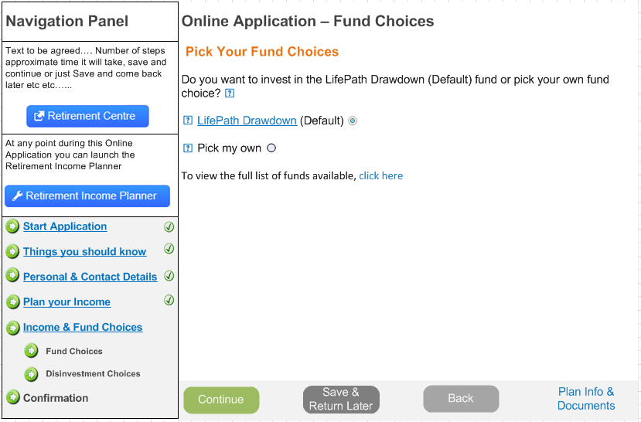

#### Fund Choices Example Screen Shot (Self Select)

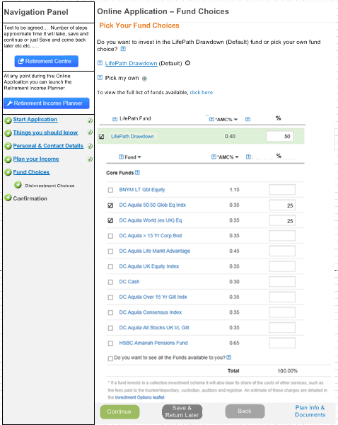

### OZUC014 – Disinvestment Choices

|  |  |
| --- | --- |
| **Use Case Reference OZUC014**  **Disinvestment Choices** | |
| **Summary** | A screen that enables the member to select the order by which the funds are used for disinvestment purposes. |
| **Actor** | Member |
| **Trigger** | Member wishing to join the BlackRock Retirement Income Account |
| **Pre- conditions** | The member has access to TargetPlan |
| **Post –conditions** | Member will have selected the order by which they want their funds disinvested from. |
| **Frequency** | Adhoc |
| **Basic Course of Action** | 1. The member selects Continue from the <<previous screen>> 2. The system checks if more than 1 fund was selected in “Fund Choices” 3. The system displays a screen to enable the member to select the order of the funds that should be disinvested from, the default will be “Pro-rated”. 4. The member leaves the default or selects the specific fund order required 5. The system updates the members account with the disinvestment fund choices details invoke *‘OZUC00? – Set Disinvestment Choices’* 6. The system displays the next screen in the “joining” suite of screens 7. The system updates the profile flags invoke ‘*OZUC00? – Update Profile Milestones’* 8. The system updates contact history *‘OZUC00? – Update Contact History’* |
| **Alternate scenario extensions** | 2a. If only one fund was selected in the fund choices step then do not display this screen during the “joining” wizard. |
| **Business Logic/ Rules/ Supplementary Info** | As part of the joining process a member needs to decide what funds they want their retirement income payments to be taken from. The options available to the member are:   * Pro-rated across all funds (which is the default) * Pick their own   This screen should only be displayed in the wizard if the member has selected more than 1 fund in the previous step. If the member has only in 1 fund (i.e. the Default LifePath or they only picked one self-select fund) then the only option is to disinvest from that 1 fund.  If however, the member has selected more than 1 fund in the previous step then upon accessing the Disinvestment Choices the following section be displayed:  Do you want us to disinvest your income using the Default Option (pro-rated across all your funds) or pick your own fund disinvestment choices?   * Default (Pro-rated) * Pick my own   The default option should be ticked upon entry to the screen.  If the member wants to select the “Default” then no further options are required and the member should select Continue to move onto the next screen in the joining suite of screens.  Pick my own  Alternatively if the member selects the “Pick my own” option the screen should then display all the funds that the member selected whilst in the “Fund Choices” screen.  The following should be present:   * Fund (including link to fund fact sheet) * Disinvestment % * Total   The member must enter the % against each fund that they would like to disinvest from. The total % must equal 100%, the Continue button should be disabled if the total does not equal 100%.  Once the member has made their Disinvestment Choices then the details need creating invoke ‘*OZUC00? – Set Up Disinvestment Choices*’ |
| **Notes / Questions** |  |
| **Includes Use Cases** |  |
| **Additional Information** |  |
| **Links to Bus Req Id** | OZ_RO_0022 |
| **Created By** | Sue Allwood |

#### Joining Disinvestment Fund Choices Screen Properties

Text in {curly brackets} needs to come from the back end system as part of the Content or from a database field.

|  |  |  |  |  |  |  |  |
| --- | --- | --- | --- | --- | --- | --- | --- |
| **Screen Header Text** (i.e. any text before the data section) | | | | | | **Can tailoring apply?** | **Target** |
| **Pick Your Disinvestment Choices**  Do you want us to disinvest your income using the Default Option (pro-rated across all your funds) or pick your own fund disinvestment choices? | | | | | | N | tba |
| **Object** | **Text** | **Mandatory** | **Validation** | **Help Icon Applies** | **Help Icon Text** | n/a | n/a |
| Tick Box | Default (Pro-Rated) | n/a | Should be ticked by default upon entry to the screen.  Cannot be selected with any of the other options | Y | To be defined | n/a | n/a |
| Tick Box | Pick my own | n/a | Cannot be selected with any of the other options  If selected displays the self-select section | Y | To be defined | n/a | n/a |
| Screen text | To view more information about your disinvestment options, click here | n/a |  | N |  | Y | Tba |
| Column Heading | Fund | n/a | Only displayed if Pick My Own selected  Sortable column | Y | To view the Fund Fact Sheet, simply click on the relevant fund link below | Y | Tba |
| Column Heading | Disinvestment % | n/a | Only displayed if Pick My Own selected  Sortable column | Y | The new % of your investments that you would like invested in the fund | Y | TBA |
| Screen Label | **Total** | n/a | Total of all the Disinvestment %’s.  Must always equal 100% | N | n/a | N | n/a |
| Button | **Continue** | n/a | Only activated if the Default is selected or once the Total = 100% | n/a | n/a | n/a | n/a |
| Button | **Save & Return Later** | n/a | Updates the profile flags for this member and exits |  |  |  |  |
| Button | **Back** | n/a | Standard “Are you sure?” message  Navigates the member back to the previous screen | n/a | n/a | N | n/a |
| Button | **Plan Info & Documents** | n/a | Link to standard Plan Information & Documents site for the scheme | n/a | n/a | N |  |
| **Screen Footer Text** (i.e. any text after the data section | | | | | | n/a | n/a |
|  | | | | | | Y | tba |

#### Disinvestment Choices Example Screen Shot (Default)

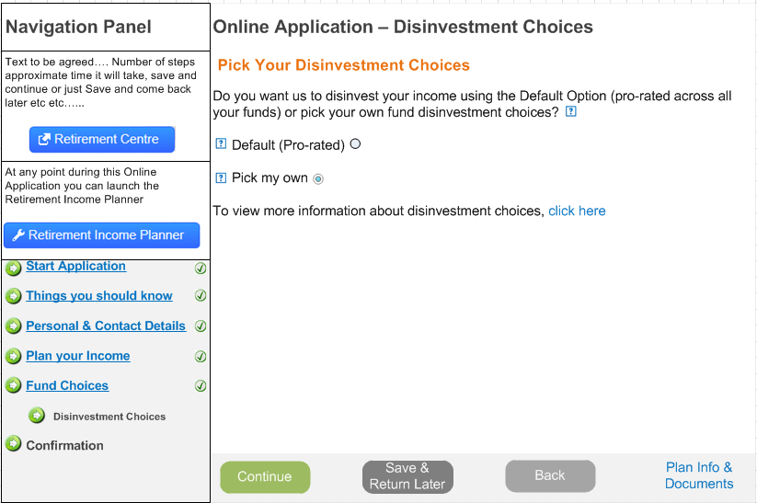

#### Disinvestment Choices Example Screen Shot (Self Select)

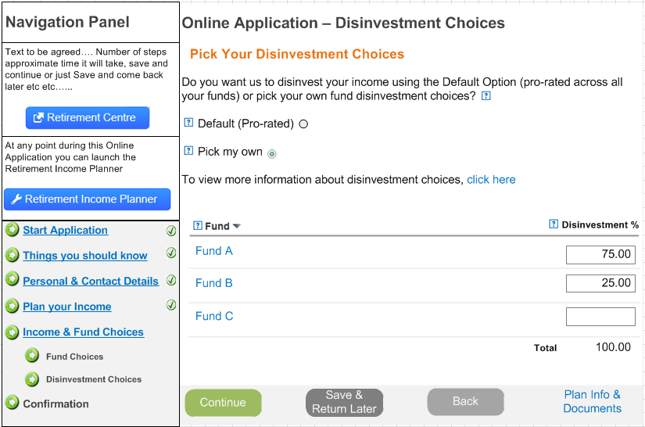

### OZUC015 – IFA Details

|  |  |
| --- | --- |
| **Use Case Reference OZUC00?**  **IFA Details** | |
| **Summary** | A screen that enables the member to enter their IFA Details for their BlackRock Retirement Income Account |
| **Actor** | Member |
| **Trigger** | Member wishing to join the BlackRock Retirement Income Account |
| **Pre- conditions** | The member has access to TargetPlan |
| **Post –conditions** | Member will have entered their bank details |
| **Frequency** | Adhoc |
| **Basic Course of Action** | 1. The member selects Continue from the <<previous screen>> 2. The system displays a screen asking the member if they consulted an IFA 3. The member selects “Yes” 4. The system displays a section to enable the member to enter their IFA Details 5. The member enters their IFA Details 6. The system saves the IFA Details invoke ‘*OZUC00? – Set IFA Details’* 7. The system displays the next screen in the “joining” suite of screens 8. The system updates the profile flags invoke ‘*OZUC00? – Update Profile Milestones’* 9. The system updates contact history *‘OZUC00? – Update Contact History’* |
| **Alternate scenario extensions** | 2a. If the member selects “No” then the system needs to store this and then the member can continue to the next screen. Invoke *‘OZUC00? – Set IFA Details’* |
| **Business Logic/ Rules/ Supplementary Info** | As part of joining the BRIA it is recommended that before the member joins that they seeks Independent Financial Advice.  Therefore as part of the application we have to ask the member if they did seek advice and if so capture the IFA details. If they didn’t seek advice then we also have to capture that they didn’t seek advice.  IFA Details  Upon accessing the screen the system should ask the member if they sort advice as follows:  Did you seek Independent Advice from an IFA before choosing to apply for the BlackRock Retirement Income Account?  If the member selects No, then the Continue button should be enabled else the IFA Details section of the screen should be displayed. The continue button should be disabled until the mandatory items are completed.  This section should have the following fields on it:   * IFA Name (mandatory) * IFA Company (mandatory) * Post Code (mandatory) – the standard Address Lookup function should be present * Address Line 1 (mandatory) * Address Line 2 * Address Line 3 * Town * County * Phone Number (mandatory) * Email Address (mandatory)   Upon selecting continue the system should store either the fact that the member didn’t seek advice or the IFA details (new UEXT tables) invoke *‘OZUC00? – Set Up IFA Details’* |
| **Notes / Questions** |  |
| **Includes Use Cases** |  |
| **Additional Information** |  |
| **Links to Bus Req Id** | OZ_RO_0019 |
| **Created By** | Sue Allwood |

#### IFA Details Screen Properties

Text in {curly brackets} needs to come from the back end system as part of the Content or from a database field.

|  |  |  |  |  |  |  |  |
| --- | --- | --- | --- | --- | --- | --- | --- |
| **Screen Header Text** (i.e. any text before the data section) | | | | | | **Can tailoring apply?** | **Target** |
| **IFA Appointed?**  Did you seek Independent Advice from an IFA before choosing to apply for the BlackRock Retirement Income Account? | | | | | | Y | tba |
| **Object** | **Text** | **Mandatory** | **Validation** | **Help Icon Applies** | **Help Icon Text** | n/a | n/a |
| Radio Button | Yes | Y | Either Yes or No must be selected  If Yes selected Display the IFA Details section of the screen  If Yes is selected disable the “Continue” button. | N |  | n/a | n/a |
| Radio Button | No | Y | Either Yes or No must be selected | N |  |  |  |
| Section Text | To be defined | N | n/a | N |  | Y | tba |
| Section Heading | **IFA Details** | n/a | Standard minimize/maximize button | n/a | n/a | n/a | n/a |
| Section Text | If you did seek Independent Advice then you must tell us the details of your Advisor: | n/a | n/a | n/a | n/a | n/a | n/a |
| Field Label | IFA Name | Y |  | Y | To be defined | n/a | n/a |
| Field Label | IFA Company | Y |  | Y | To be defined | n/a | n/a |
| Field Label | Post Code | Y |  | Y | To be defined | n/a | n/a |
| Button | Click to Find | n/a | Calls standard Address Lookup function | N | n/a | n/a | n/a |
| Field Label | Address Line 1 | Y |  | Y | To be defined | n/a | n/a |
| Field Label | Address Line 2 | N |  | N | n/a | n/a | n/a |
| Field Label | Address Line 3 | N |  | N | n/a | n/a | n/a |
| Field Label | Town | N |  | N | n/a | n/a | n/a |
| Field Label | County | N |  | N | n/a | n/a | n/a |
| Field Label | Phone Number | Y | Standard phone number format validation | N | n/a | n/a | n/a |
| Field Label | Email Address | Y | Standard email address format validation | N | n/a | n/a | n/a |
| Button | **Continue** | n/a | Navigates to the next screen | n/a | n/a | N | n/a |
| Button | **Save & Return Later** | n/a | Updates the profile flags for this member and exits |  |  |  |  |
| Button | **Back** | n/a | Standard “Are you sure?” message  Navigates the member back to the previous screen | n/a | n/a | N | n/a |
| Button | **Plan Info & Documents** | n/a | Link to standard Plan Information & Documents site for the scheme | n/a | n/a | N |  |
| **Screen Footer Text** (i.e. any text after the data section | | | | | | n/a | n/a |
| Items marked with a * are mandatory | | | | | | Y | tba |

#### IFA Details Example Screen Shot (No IFA)

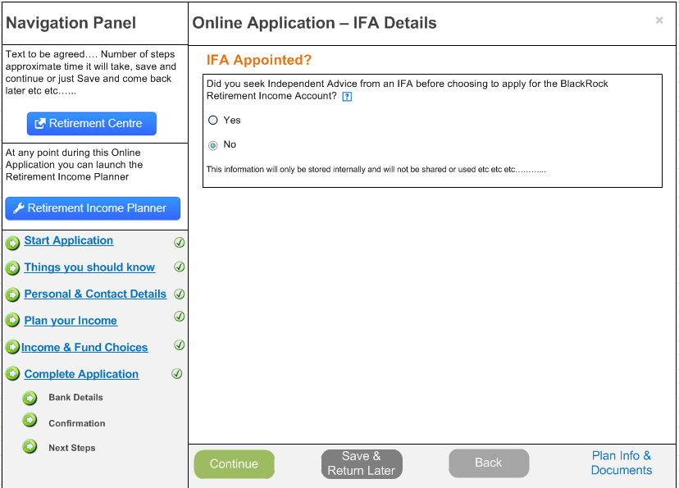

#### IFA Details Example Screen Shot (with IFA)

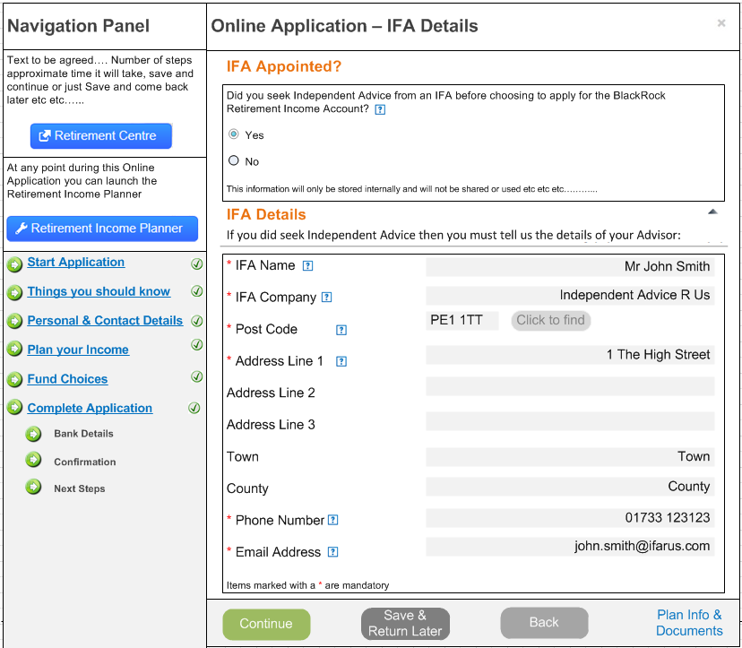

### OZUC016 –Bank Details

|  |  |
| --- | --- |
| **Use Case Reference OZUC00?**  **Bank Details** | |
| **Summary** | A screen that enables the member to enter and validate bank account details |
| **Actor** | Member |
| **Trigger** | Member wishing to join the BlackRock Retirement Income Account |
| **Pre- conditions** | The member has access to TargetPlan |
| **Post –conditions** | Member will have entered and validated bank account details |
| **Frequency** | Adhoc |
| **Basic Course of Action** | 1. The member selects Continue from the <<previous screen>> 2. The system checks to see if the member requested “Regular Income” in the “Income” step 3. The system displays a screen to enable the member to enter their bank/building society account details where they want to have their retirement income paid. 4. The member completes the details required to capture their bank/building society account information 5. The system validates the bank account details entered invoke ‘*OZUC00? – Validate Bank Details*’ 6. The member continues the joining process either confirming or changing the data as required. 7. The system updates the members account with the bank/building society details invoke *‘OZUC00? – Store Bank Details’* 8. The system displays the next screen in the “joining” suite of screens 9. The system updates the profile flags invoke ‘*OZUC00? – Update Profile Milestones’* 10. The system updates contact history *‘OZUC00? – Update Contact History’* |
| **Alternate scenario extensions** | 4a. Invalid Bank Account  If the bank account validation fails then present a message on the screen to the member asking them to check the details entered and to re-enter, if following this the bank account details are still invalid then a work item should be created, invoke ‘*OZUC00? – Create Work Item*’ |
| **Business Logic/ Rules/ Supplementary Info** | Bank Account Details  The screen should have the following items on it:   * Bank or Building Society selector   If bank selected:   * Name of Bank * Account Number * Re-Enter Account Number * Sort Code * Re-Enter Sort Code * Name of Account Holder   If building society selected:   * Name of Building Society * Account Number * Re-Enter Account Number * Sort Code * Re-Enter Sort Code * Name of Account Holder * Roll/Reference Number   Upon entering the bank details the system needs to validate that the bank account details are valid, that they belong to the member that is applying for the account and that the bank account is not an overseas bank account invoke – *‘OZUC00? – Validate Bank Details’*. If any of these checks fail then an error message should be displayed, for example:  The bank account details entered and not valid, please check and re-enter correct details.  If after re-entering the details the checks still fails then a work item should be created to enable the Admin Centre to contact the member to confirm if the bank details make the member ineligible to join or not, invoke *‘OZUC00? – Create Work Item’*.  Upon entering the bank details the system needs to store them, using secure encryption invoke *‘OZUC00? – Store bank details’* |
| **Notes / Questions** | 1. The requirements say that before the member can enter their bank account details they need to re-enter their security questions and answers, is that really required when in create mode? Definitely when they amend, but there’s nothing here captured at the moment to seems over the top! 2. What do we do if the bank account details fail validation, but upon checking with the member/obtaining proof they are their details, need some sort of override! 3. Bank account checking levels/validation software? 4. Compass currently doesn’t store bank account in encrypted format! |
| **Includes Use Cases** |  |
| **Additional Information** | The following was referenced to determine format and rules around account numbers etc:  [http://www.paymentscouncil.org.uk/files/payments_files/ account_number_best_practice_guidelines_june_09.pdf](http://www.paymentscouncil.org.uk/files/payments_files/%20account_number_best_practice_guidelines_june_09.pdf)  <http://www.nationwide.co.uk/support/support-articles/manage-your-account/sort-code-and-account-number-information> |
| **Links to Bus Req Id** | OZ_RO_0020 |
| **Created By** | Sue Allwood |

#### Bank Details Screen Properties

Text in {curly brackets} needs to come from the back end system as part of the Content or from a database field.

|  |  |  |  |  |  |  |  |
| --- | --- | --- | --- | --- | --- | --- | --- |
| **Screen Header Text** (i.e. any text before the data section) | | | | | | **Can tailoring apply?** | **Target** |
| **Bank/Building Society Details**  Please tell us where you would like your regular income paid? | | | | | | Y | tba |
| **Object** | **Text** | **Mandatory** | **Validation** | **Help Icon Applies** | **Help Icon Text** | n/a | n/a |
| Radio Button | Bank | Y | Either Bank or Building Society must be selected. If Bank selected then display the fields applicable to a Bank. | N | n/a | n/a | n/a |
| Radio Button | Building Society | Y | Either Bank or Building Society must be selected. If Building Society selected then display the fields applicable to a Building Society | N | n/a | n/a | n/a |
| On Screen Warning | As part of our checking process we need to confirm the details provided against a Credit Reference Agency (CRA). A record of this check is stored by the CRA. It is not used in any credit risk scoring and does not affect credit ratings in any way. | n/a | On screen warning | N | n/a | n/a | n/a |
| Field Label | Name of Bank or Name of Building Society | Y |  | Y | To be defined | n/a | n/a |
| Field Label | Account Number | Y | 8 numeric  Mask this field upon moving to the next field so the user cannot see what they entered so doesn’t purely copy in case of a typo | Y | To be defined | n/a | n/a |
| Field Label | Re-Enter Account Number | Y | 8 numeric  Must match exactly to the Account Number entered in the previous field | Y | To be defined | n/a | n/a |
| Field Label | Sort Code | Y | 6 (3 lots of 2) | Y | To be defined | n/a | n/a |
| Field Label | Re-Enter Sort Code | Y | 6 (3 lots of 2)  Must match exactly to the Sort Code entered in the previous field | Y | To be defined | n/a | n/a |
| Field Label | Name of Account Holder | Y |  | Y | To be defined | n/a | n/a |
| Field Label | Roll/Reference Number | N | No standardized formation  On display if Building Society selected | Y | To be defined | n/a | n/a |
| Button | **Continue** | n/a | Navigates to the next screen | n/a | n/a | N | n/a |
| Button | **Save & Return Later** | n/a | Updates the profile flags for this member and exits – should this invoke the standard log out routine? |  |  |  |  |
| Button | **Back** | n/a | Standard “Are you sure?” message  Navigates the member back to the previous screen | n/a | n/a | N | n/a |
| Button | **Plan Info & Documents** | n/a | Link to standard Plan Information & Documents site for the scheme | n/a | n/a | N |  |
| **Screen Footer Text** (i.e. any text after the data section | | | | | | n/a | n/a |
| n/a | | | | | | Y | tba |

#### Bank Details Example Screen Shot

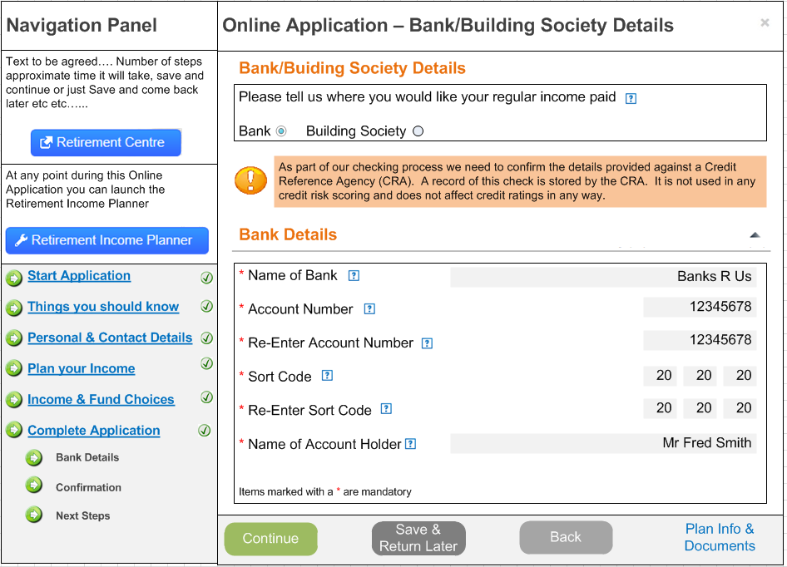

#### Building Society Example Screen Shot

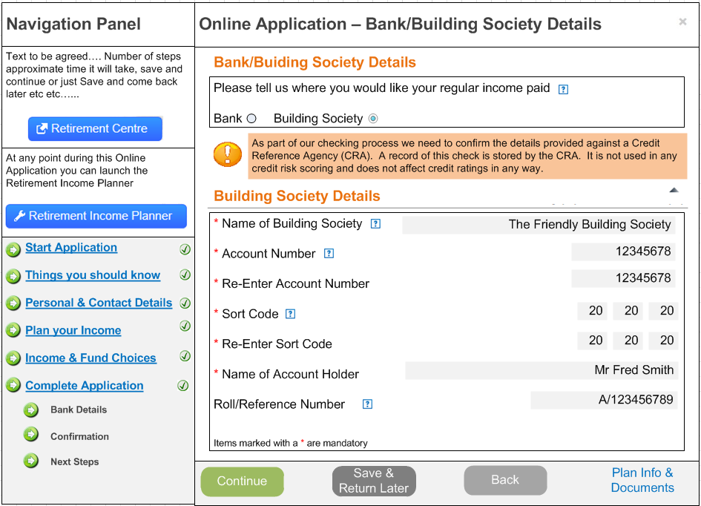

### OZUC017 – Confirmation

|  |  |
| --- | --- |
| **Use Case Reference OZUC00?**  **Confirmation** | |
| **Summary** | A screen that confirms all the details entered during the online joining process. |
| **Actor** | Member |
| **Trigger** | Member wishing to join the BlackRock Retirement Income Account |
| **Pre- conditions** | The member has access to TargetPlan |
| **Post –conditions** | Member confirms all details are correct and proceeds with the application |
| **Frequency** | Adhoc |
| **Basic Course of Action** | 1. The member selects Continue from the <<previous screen>> 2. The system displays a screen that replays all of the selections made by the member. 3. The member reviews the selections and confirms they are correct 4. The member continues the joining process 5. The system updates the profile flags invoke ‘*OZUC00? – Update Profile Milestones’* 6. The system updates contact history *‘OZUC00? – Update Contact History’* 7. The system creates any work items required ‘*OZUC00? – Create Work Item’* 8. The system displays the next screen in the “joining” suite of screens |
| **Alternate scenario extensions** | 3a. The member wants to amend any of the selections in which case they need to navigate back to the applicable screen and enter any changes. If the member does make any changes the system should update the appropriate part of the system and also unwind/update any profile milestones. |
| **Business Logic/ Rules/ Supplementary Info** | 2. Confirmation Screen  Once the member has completed all the sections of the joining wizard they should be presented with a summary of the details they have entered on the previous screens. The screen should be made up of the following sections:   * Congratulations   + Text confirm details of the previous and next steps * Important Information & Policy Conditions   + You have read and understood the Guidance Guarantee   + You have read and understood the Money Purchase Annual Allowance   + You have read and accepted the Policy Terms and Conditions   + You have read and understood the Key Features documentation   + You have read and understood the Investment Options * Income   + Display details of the income details entered   + Also a message will need displaying to the member advising them of when their first payment will be made. This needs to tie in with the day of the month and payroll/disinvestment timeline/calendar once more known. * Fund Choices   + Fund choice selection * Disinvestment Choices   + Disinvestment Choice selection * IFA Details   + IFA details entered (if any) * Bank Details   + Bank details entered (if any)   Each section should display the details completed by the member rather than all the fields on all the screens.  The member should also be given the opportunity to download to PDF to enable them to save locally.  7. System Updates  Once the member has confirmed that they are happy with the details they have entered and have confirmed this various system updates need to be fired as follows:   * Update the profile milestones invoke *‘OZUC00? – Update Profile Milestones’* * Create a work item to request proof of age invoke ‘*OZUC00? – Create Work Item’* (assuming this is actually the one to create the Retirement Application Pack) * Create a work item to run and send the Illustration ‘*OZUC00? – Create Work Item.* Is this one work item for both or two work items? * Update contact history invoke *‘OZUC00? – Create Contact History’* |
| **Notes / Questions** |  |
| **Includes Use Cases** |  |
| **Additional Information** |  |
| **Links to Bus Req Id** | OZ_RO_0025 |
| **Created By** | Sue Allwood |

#### Confirmation Screen Properties

Text in {curly brackets} needs to come from the back end system as part of the Content or from a database field.

|  |  |  |  |  |  |  |  |
| --- | --- | --- | --- | --- | --- | --- | --- |
| **Screen Header Text** (i.e. any text before the data section) | | | | | | **Can tailoring apply?** | **Target** |
| **Congratulations**  **{BlackRock Retirement Income Account} Application**  You have now told us everything that we need to know to proceed with you application to join the BlackRock Retirement Income Account. Before confirming that you want to continue with this application please review the details below. If you need to change any of these details please navigate to the application section and amend as required. | | | | | | Y | tba |
| **Object** | **Text** | **Mandatory** | **Validation** | **Help Icon Applies** | **Help Icon Text** | n/a | n/a |
| Section Heading | **Important Information & Policy Conditions** | n/a | Standard maximize/minimize button | N | n/a | n/a | n/a |
| On screen text | You have read and understood the Guidance Guarantee | n/a | Brought forward from previous section | N | n/a | n/a |  |
| On screen text | You have read and understood the Money Purchase Annual Allowance | n/a | Brought forward from previous section | N | n/a | n/a |  |
| On screen text | You have read and accepted the Policy Terms and Conditions | n/a | Brought forward from previous section | N | n/a | n/a |  |
| On screen text | You have read and accepted the Key Features | n/a | Brought forward from previous section | N | n/a | n/a |  |
| On screen text | You have read and accepted the Investment Options details | n/a | Brought forward from previous section | N | n/a | n/a |  |
| Section Heading | **Income Details** | n/a | Standard maximize/minimize button  This section is variable depending upon what was completed in the Income Screen | N | n/a | n/a |  |
| Section Text | You have asked for the following Income in Retirement: | n/a | n/a | N | n/a | n/a |  |
| On screen message | Your first Income Payment will be paid on or around dd/mm/yyyy which is the next scheduled payment run. | n/a | n/a | n/a | n/a | n/a | n/a |
| Field Label | Tax Free Cash Lump Sum | n/a | Present if the member selected Tax Free Cash in the Income Screen income in the Income Screen  View Only | Y | To be defined | n/a | n/a |
| Field Label | Retirement Income Fund | n/a | Present if the member selected Income in the Income Screen  View Only | Y | To be defined | n/a | n/a |
| Field Label | Gross Income Account | n/a | Present if the member selected Income in the Income Screen  View Only | Y | To be defined | n/a | n/a |
| Field Label | Payment Frequency | n/a | Present if the member selected Income in the Income Screen  View Only | Y | To be defined | n/a | n/a |
| Field Label | Escalation | n/a | Present if the member selected Income in the Income Screen  View Only | Y | To be defined | n/a | n/a |
| Field Label | Amount Required to purchase an Annuity | n/a | Present if the member selected an Annuity in the Income Screen  View Only | Y | To be defined | n/a | n/a |
| Section Heading | **Fund Choices** | n/a | Standard maximize/minimize button | N | n/a | n/a | n/a |
| Section Text | You have asked for the following fund choices: | n/a | n/a | n/a | n/a | n/a | n/a |
| Column Heading | Fund Choice | n/a | Display the list of funds selected on the fund choices screen | Y | To be defined | n/a | n/a |
| Column Heading | % | n/a | Display the % selected for each of the funds on the fund choices screen | Y | To be defined | n/a | n/a |
| Section Heading | **Disinvestment Choices** | n/a | Standard maximize/minimize button | N | n/a | n/a | n/a |
| Section Text | You have asked for the following disinvestment choices: | n/a | n/a | n/a | n/a | n/a | n/a |
| Field Label | Default (Pro-Rated) | n/a | If Default selected | Y | To be defined | n/a | n/a |
| Column Heading | Fund Choice | n/a | If pick my own selected:  Display the list of funds selected on the disinvestment choices screen | Y | To be defined | n/a | n/a |
| Column Heading | % | n/a | If pick my own selected:  Display the % selected for each of the funds on the disinvestment choices screen | Y | To be defined | n/a | n/a |
| Section Heading | **IFA Details** | n/a | Standard maximize/minimize button  Only display this section if an IFA was consulted | N | n/a | n/a | n/a |
| Section Text | You provided the following information about your IFA | n/a | n/a | N | n/a | n/a | n/a |
| Field Label | IFA Name | n/a | IFA Name if an IFA was consulted | Y | To be defined | n/a | n/a |
| Field Label | IFA Company | n/a | IFA Company if an IFA was consulted | Y | To be defined | n/a | n/a |
| Field Label | Post Code | n/a | IFA Post Code if an IFA was consulted | Y | To be defined | n/a | n/a |
| Field Label | Address Line 1 | n/a | IFA Address Line 1 if an IFA was consulted | Y | To be defined | n/a | n/a |
| Field Label | Address Line 2 | n/a | IFA Address Line 2 if an IFA was consulted and address line 2 been completed | N | n/a | n/a | n/a |
| Field Label | Town | n/a | IFA Town if an IFA was consulted and town been completed | N | n/a | n/a | n/a |
| Field Label | County | n/a | IFA County if an IFA was consulted and county been completed | N | n/a | n/a | n/a |
| Field Label | Phone Number | n/a | IFA Phone Number if an IFA was consulted | N | n/a | n/a | n/a |
| Field Label | Email Address | n/a | IFA Town if an IFA was consulted and town | N | n/a | n/a | n/a |
| Section Heading | **Bank Details** | n/a | Standard maximize/minimize button  Only display this section if bank details are present | N | n/a | n/a | n/a |
| Section Text | You want your income paid into the following account: | n/a | n/a | N | n/a | n/a | n/a |
| Field Label | Name of Bank | n/a | Bank name if bank selected and entered |  |  |  |  |
| Field Label | Name of Building Society | n/a | Building Society name and bank selected |  |  |  |  |
| Field Label | Account Number | n/a | Account Number | N | n/a | n/a | n/a |
| Field Label | Roll/Reference Number | n/a | Building Society reference number if present | N | n/a | n/a | n/a |
| Field Label | Name of Account Holder | n/a | Account Holder name if present | N | n/a | n/a | n/a |
| Section Heading | **Confirmation** | n/a | Standard maximize/minimize button | N | n/a | n/a | n/a |
| Section Text | Please read the notes below and confirm you want to join the scheme: | n/a | n/a | N | n/a | n/a | n/a |
| Screen Text | {**BlackRock Retirement Income Account Application**} | n/a | Scheme name from back end system | N | n/a | n/a | n/a |
| Screen Text | Words need defining………….. | n/a | Content from back end system | N | n/a | n/a | n/a |
| Tick Box | **I confirm words………** | n/a | Content from back end system | N | n/a | n/a | n/a |
| Tick Box | I would like to change……. | n/a | Content from back end system | N | n/a | n/a | n/a |
| Down Load Icon |  | n/a | n/a | n/a | n/a | n/a | n/a |
| Button | **Back** | n/a | Standard “Are you sure?” message  Navigates the member back to the previous screen | n/a | n/a | N | n/a |
| Button | **Continue** | n/a | Completes the process and invokes all the required updates to create the new account, trigger any work items, update any audit logs and trigger any communications. | n/a | n/a | N | n/a |
| Button | **Plan Info & Documents** | n/a | Link to standard Plan Information & Documents site for the scheme | n/a | n/a | N |  |
| **Screen Footer Text** (i.e. any text after the data section | | | | | | n/a | n/a |
| n/a | | | | | | Y | tba |

#### Confirmation Screen Example Screen Shot

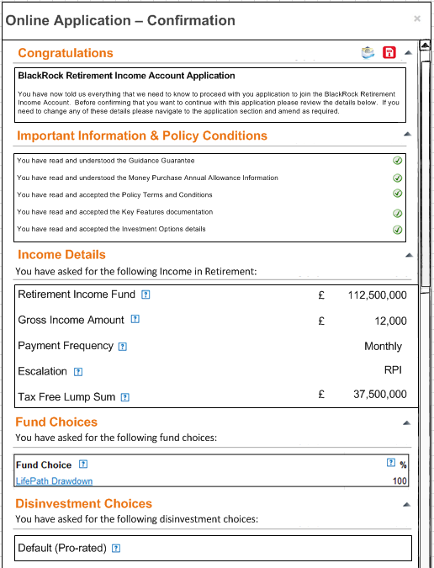

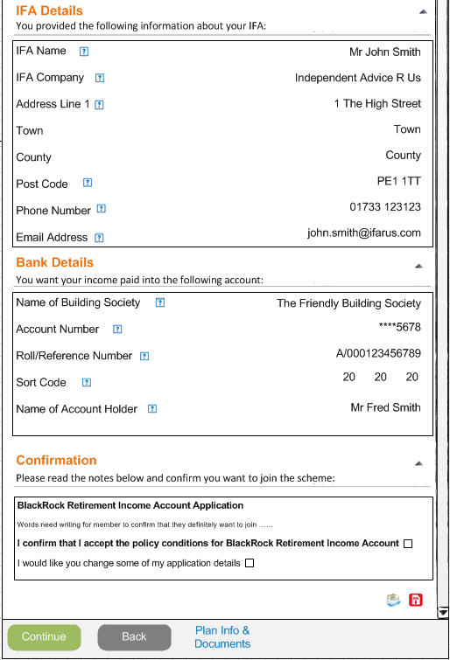

### OZUC018 – Next Steps

|  |  |
| --- | --- |
| **Use Case Reference OZUC00?**  **Next** | |
| **Summary** | A screen that confirms the next steps of the joining process |
| **Actor** | Member |
| **Trigger** | Member wishing to join the BlackRock Retirement Income Account |
| **Pre- conditions** | The member has access to TargetPlan |
| **Post –conditions** | Member reads the next steps and Exits |
| **Frequency** | Adhoc |
| **Basic Course of Action** | 1. The member selects Continue from the <<previous screen>> 2. The system displays a screen that advises the member of the next steps 3. The member reviews the next steps 4. The system updates the profile flags invoke ‘*OZUC00? – Update Profile Milestones’* 5. The system updates contact history *‘OZUC00? – Update Contact History’* 6. The system creates any work items required ‘*OZUC00? – Create Work Item’* 7. The system displays the next screen in the “joining” suite of screens |
| **Alternate scenario extensions** | 3a. The member wants to amend any of the selections in which case they need to navigate back to the applicable screen and enter any changes. If the member does make any changes the system should update the appropriate part of the system and also unwind/update any profile milestones. |
| **Business Logic/ Rules/ Supplementary Info** | 2. Confirmation Screen  Once the member has completed all the sections of the joining wizard they should be presented with a summary of the details they have entered on the previous screens. The screen should be made up of the following sections:   * Summary   + You have read and understood the Guidance Guarantee   + You have read and understood the Money Purchase Annual Allowance   + You have read and accepted the Policy Terms and Conditions   + You have read and understood the Key Features documentation   + You have read and understood the Investment Options   + You have completed all the steps required   + You have received your Personal Illustration * Next Steps   + Text section * Confirmation   + Confirmation check box   System Updates  Once the member has confirmed they definitely want to join   * Update the profile milestones invoke *‘OZUC00? – Update Profile Milestones’* * Create a work item to request proof of age invoke ‘*OZUC00? – Create Work Item’* * Create a work item to run and send the Illustration ‘*OZUC00? – Create Work Item.* Is this one work item for both or two work items? * Update contact history invoke *‘OZUC00? – Create Contact History’* |
| **Notes / Questions** |  |
| **Includes Use Cases** |  |
| **Additional Information** |  |
| **Links to Bus Req Id** | OZ_RO_0025 |
| **Created By** | Sue Allwood |

#### Next Steps Screen Properties

Text in {curly brackets} needs to come from the back end system as part of the Content or from a database field.

|  |  |  |  |  |  |  |  |
| --- | --- | --- | --- | --- | --- | --- | --- |
| **Screen Header Text** (i.e. any text before the data section) | | | | | | **Can tailoring apply?** | **Target** |
|  | | | | | | Y | tba |
| **Object** | **Text** | **Mandatory** | **Validation** | **Help Icon Applies** | **Help Icon Text** | n/a | n/a |
| Section Heading | **Summary** | n/a | Standard maximize/minimize button | N | n/a | n/a | n/a |
| On screen text | You have read and understood the Guidance Guarantee | n/a | Brought forward from previous section | N | n/a | n/a |  |
| On screen text | You have read and understood the Money Purchase Annual Allowance | n/a | Brought forward from previous section | N | n/a | n/a |  |
| On screen text | You have read and accepted the Policy Terms and Conditions | n/a | Brought forward from previous section | N | n/a | n/a |  |
| On screen text | You have read and accepted the Key Features | n/a | Brought forward from previous section | N | n/a | n/a |  |
| On screen text | You have read and accepted the Investment Options details | n/a | Brought forward from previous section | N | n/a | n/a |  |
| On screen text | Your have completed all the steps required | n/a | Brought forward from previous section |  |  |  |  |
| On screen text | Your have received your Personal Illustration | n/a | Brought forward from previous section |  |  |  |  |
| Section Heading | **Next Steps** | n/a | Standard maximize/minimize button | N | n/a | n/a |  |
| Section Text | This is what will happen next: | n/a | n/a | N | n/a | n/a |  |
| On screen text | To be defined | n/a |  |  |  |  |  |
| Section Heading | **Confirmation** | n/a | Standard maximize/minimize button | N | n/a | n/a | n/a |
| Section Text | Please read the notes below and confirm you want to join the scheme: | n/a | n/a | N | n/a | n/a | n/a |
| Screen Text | {**BlackRock Retirement Income Account Application**} | n/a | Scheme name from back end system | N | n/a | n/a | n/a |
| Screen Text | Words need defining………….. | n/a | Content from back end system | N | n/a | n/a | n/a |
| Tick Box | **I confirm words………** | n/a | Content from back end system | N | n/a | n/a | n/a |
| Tick Box | I would like to change……. | n/a | Content from back end system | N | n/a | n/a | n/a |
| Button | **Back** | n/a | Standard “Are you sure?” message  Navigates the member back to the previous screen | n/a | n/a | N | n/a |
| Button | **Continue** | n/a | Completes the process and invokes all the required updates to create the new account, trigger any work items, update any audit logs and trigger any communications. | n/a | n/a | N | n/a |
| Button | **Plan Info & Documents** | n/a | Link to standard Plan Information & Documents site for the scheme | n/a | n/a | N |  |
| **Screen Footer Text** (i.e. any text after the data section | | | | | | n/a | n/a |
| n/a | | | | | | Y | tba |

#### Next Steps Screen Example Screen Shot

#### 

## Use Case Diagram – New Target Plan Screens

Insert diagram

This section will be written and distributed in the next version of the document.